Arab Academy for Science, Technology, and Maritime Transport College of Computing and Information Technology
Smart Village

autoMITRE: AI-Powered Threat Intelligence and Mitigation System

Graduation Project

A Thesis submitted in partial fulfillment of the requirements of B.Sc. in “CyberSecurity.”

by
Moustafa Ahmed Elsayed - 221027722
Abd El-Rahman Mohammed Abd-Eltawab - 221027660
Hashem Abdo Hashem - 221010840
Mira Amin - 221027418
Jana Wael - 221027512
Jomana Mohsen - 221027807
College of Computing and Information Technology, AASTMT

Supervised By
Dr. Ahmed Maher Moustafa

Contents
Abstract 4
Acknowledgment 5
List of Figures 6
List of Tables 7
Chapter 1 - Introduction 1
1.1 Motivation 1
1.2 Problem Statement 2
1.3 Problem Complexity 2
1.4 Objectives 4
1.5 Constraints 6
1.6 Standards 6
1.7 Feasibility Study and Business Canvas 7
1.8 Thesis Organization 8
Chapter 2 – Background 3
2.1 Background 3
2.1.1 Cyber Threat Modeling 3
2.1.2 Cybersecurity Frameworks and Standards 4
2.1.3 Artificial Intelligence and NLP in Cybersecurity 5
2.1.4 Security Information and Event Management (SIEM) Systems 5
2.1.5 Adaptive Learning and Threat Prediction 6
2.1.6 Summary Of Background 6
Chapter 3 – Related Work and Similar Systems 7
3.1 Related Work 7
3.2 Similar Systems 8
3.3 Comparison Summary 10
3.4 AutoMITRE Contribution 10
Chapter 4 - Analysis 12
Software Requirements Specifications IEEE 830 12
4.1 Functional Requirements (FRs) 12
4.2 Non-Functional Requirements (NFRs) 15
NFR1 — Performance Requirements 15
NFR2 — Availability 15
NFR3 — Scalability 16
NFR4 — Reliability & Fault Tolerance 16
NFR5 — Security Requirements 17
NFR6 — Usability 17
NFR7 — Maintainability 17
NFR8 — Interoperability 18
4.3 Primary Stakeholders 18
4.3.1 End Users (Cybersecurity Analysts / SOC Analysts) 18
4.3.2 System Administrators 19
4.4 Secondary Stakeholders 19
4.4.1 Security Engineers / Threat Hunters 19
4.4.2 Incident Response Teams (IR Teams) 19
4.4.3 Compliance & Governance Teams 19
4.5 Technical Stakeholders 19
4.5.1 Developers + AI engineers (separated) 19
4.5.2 API Providers (External Systems) 19
4.6 External Integration Stakeholders 20
4.6.1 SIEM Systems 20
4.7 Indirect Stakeholders 20
4.7.1 Organizations Using the Tool 20
4.7.2 Future Developers / Researchers 20
Chapter 5 - Design 21
5.1 Design Alternatives 21
5.2 UML Diagrams 25
5.3 Technologies and Tools Used 33
5.3.1 Programming Languages 33
5.3.2 Backend Frameworks 33
5.3.3 Artificial Intelligence, Deep Learning, LLMs, and RAG 33
5.3.4 Cybersecurity Frameworks 34
5.3.5 External APIs & Integrations 34
5.3.6 Data Processing & File Handling 35
5.3.7 Frontend & Visualization 35
5.3.8 Design & Prototyping Tools 36
5.3.9 Development & Deployment Environment 36
5.4 Prototype 37
Chapter 6 - Implementation 41
6.1 Implementation Environment 41
6.2 Backend Implementation 41
6.3 Frontend Implementation 43
6.4 Results and Discussion 43
Chapter 7 - Testing 44
Software Test Plan (IEEE 829) 44
7.1 Introduction 44
7.2 Test Items 44
7.3 Features to be Tested 44
7.4 Features Not to be Tested 44
7.5 Testing Approach 44
7.6 Environmental Needs 47
7.7 Test Results and Validation 47
7.8 Conclusion of Testing 48
Chapter 8 - Conclusion and Future Work 48
8.1 Conclusion 48
8.2 Limitations 48
8.3 Future Work 49
References 49
Appendix A - Senior Project Summary Report 50

Smart Village, Cairo, 2025-2026

Abstract
The rapid evolution of cyber threats has created an urgent demand for intelligent, automated, and unified cybersecurity solutions. Traditional defensive mechanisms, although effective within their scope, often operate in isolation and rely heavily on manual interpretation. Cybersecurity analysts depend on multiple specialized tools such as Microsoft Threat Modeling Tool (TMT), OWASP Threat Dragon, IriusRisk, VirusTotal, and Security Information and Event Management (SIEM) systems to identify and mitigate vulnerabilities. However, these tools lack integration and contextual awareness, leading to fragmented analyses, duplicated efforts, and slower incident response.
This project introduces AutoMITRE — an AI-Powered Threat Intelligence and Mitigation System, designed to unify, automate, and enhance the threat analysis process across multiple data sources and frameworks. AutoMITRE accepts diverse input formats, including textual threat descriptions, JSON exports from threat modeling tools, HTML threat and risk reports, CSV/Excel tabular data, PCAP network captures, malware hashes, and system or application logs. Using Artificial Intelligence (AI) and Natural Language Processing (NLP), the system semantically analyzes these inputs to detect threats, categorize attack behaviors, and correlate them with industry-standard frameworks such as MITRE ATT&CK, MITRE D3FEND, NIST 800-53, and OWASP ASVS.
Unlike conventional tools, AutoMITRE goes beyond static analysis. It employs an adaptive learning and predictive intelligence model that studies historical patterns to forecast future threat trends and potential attack vectors. The system then generates explainable, step-by-step mitigation strategies, providing cybersecurity professionals with actionable recommendations that align with standardized defense frameworks.
AutoMITRE further integrates seamlessly with existing security ecosystems by exporting results in SIEM-compatible formats (JSON, CSV, and STIX 2.1). This allows the intelligence it produces to be directly ingested by platforms such as Splunk, QRadar, Elastic Security, and Wazuh, enabling proactive defense, automated correlation, and improved situational awareness.
By merging threat modeling, AI-driven analytics, and multi-framework mapping within a single platform, AutoMITRE reduces manual workload, enhances accuracy, and transforms fragmented data into actionable, predictive intelligence. This research aims to bridge the existing gap between static threat analysis and dynamic, AI-enhanced mitigation — paving the way for future intelligent cybersecurity ecosystems capable of anticipating threats before they occur.

Acknowledgment
The successful completion of this project would not have been possible without the invaluable support, guidance, and encouragement of several individuals and institutions to whom we owe our deepest gratitude.
First and foremost, we would like to express our profound appreciation to our supervisor, Dr. Ahmed Maher Moustafa, for his exceptional guidance, insightful advice, and unwavering support throughout every stage of the project. His expertise in cybersecurity and research direction played a vital role in shaping the vision and execution of this work.
We extend our sincere thanks to the College of Computing and Information Technology (CCIT) at the Arab Academy for Science, Technology and Maritime Transport (AASTMT) for providing a strong academic foundation, technical resources, and a collaborative research environment that made this project possible.
Special thanks are due to our professors, teaching assistants, and peers who contributed valuable feedback, shared knowledge, and helped refine the technical and analytical aspects of this research. Their input significantly enriched the quality of the project and enhanced our understanding of advanced cybersecurity principles.
We would also like to acknowledge the open-source and cybersecurity research communities whose tools, datasets, and frameworks — including MITRE, OWASP, and NIST — formed the backbone of this study. Their commitment to global collaboration and transparency in cybersecurity inspired the development of this project.
Finally, we express our heartfelt gratitude to our families and friends for their constant motivation, patience, and encouragement throughout our academic journey. Their belief in us has been a continuous source of strength and determination.
To everyone who contributed, directly or indirectly, to the success of AutoMITRE, we extend our deepest thanks and appreciation.

List of Figures

Figure 1: Enhanced Entity Relationship Diagram (EERD) 19
Figure 2: Use Case Diagram 20
Figure 3: Activity Diagram 21
Figure 4: Class Diagram 22
Figure 5: Data Flow Diagram Level 0 23
Figure 6: Data Flow Diagram Level 1 24
Figure 7: Data Flow Diagram Level 2 25
Figure 8: Sequence Diagram 26
Figure 9: State Machine Diagram 26
Figure 10: Flowchart Diagram 27

List of Tables

Table 1: Standards table 15
Table 2: comparison of similar systems 10

Chapter 1 - Introduction

In recent years, the cybersecurity landscape has undergone a dramatic transformation, characterized by the rapid emergence of advanced and persistent cyber threats targeting organizations of all sizes. As the attack surface expands through cloud computing, IoT, and interconnected digital systems, traditional manual approaches to threat analysis and mitigation have become increasingly inadequate. Security analysts now face an overwhelming amount of data generated by various tools and platforms, often leading to delayed responses and overlooked vulnerabilities. The growing complexity of these threats highlights the need for intelligent, automated systems capable of not only identifying and analyzing risks from multiple sources but also providing actionable, framework-aligned mitigation strategies. This pressing need for unified, AI-driven cybersecurity analysis forms the foundation and motivation for developing AutoMITRE, an advanced platform designed to bridge the gap between threat modeling, intelligence correlation, and proactive defense.

Motivation
In today’s digital age, cyber threats are evolving faster than the tools designed to defend against them. Organizations face a continuous surge of sophisticated attacks ranging from ransomware and phishing to advanced persistent threats (APTs) and insider exploits. The complexity of modern cyberattacks requires multi-layered defense mechanisms supported by continuous threat analysis, intelligence correlation, and proactive mitigation strategies.
To manage this, cybersecurity teams rely on a diverse ecosystem of tools, such as Microsoft Threat Modeling Tool (TMT) for system-level threat identification, OWASP Threat Dragon and IriusRisk for risk modeling, VirusTotal for malware intelligence, and SIEM (Security Information and Event Management) systems like Splunk, Wazuh, and QRadar for event correlation and alerting.
However, these tools work in isolation, each focusing on a single domain. For example:
- Threat modeling tools produce design-time reports but lack dynamic analysis.
- SIEM systems collect runtime logs but lack predictive and contextual mapping.
- Malware intelligence platforms identify known signatures but cannot predict or explain attack trends.
This fragmentation creates a gap in situational awareness. Security analysts must manually correlate information between tools, cross-reference multiple frameworks like MITRE ATT&CK, MITRE D3FEND, and NIST 800-53, and derive mitigations manually — a process that is slow, error-prone, and reactive rather than proactive.
This challenge motivates the creation of AutoMITRE, an AI-powered system that can bridge these gaps by providing a unified, automated, and intelligent approach to threat analysis, framework mapping, and mitigation recommendation. By integrating artificial intelligence and threat modeling principles, AutoMITRE aims to empower cybersecurity teams with contextual, predictive, and actionable insights — transforming raw data into meaningful, defense-oriented intelligence.

Problem Statement

Despite the wide availability of cybersecurity tools, organizations continue to suffer from delayed incident response and poor threat correlation due to tool fragmentation and lack of automation. Current workflows depend heavily on human analysts to:
- Collect and interpret threat modeling reports.
- Analyze network traffic or PCAP files.
- Manually map findings to frameworks like MITRE ATT&CK or OWASP ASVS.
- Search for relevant mitigations or defensive strategies.
These manual efforts are not only time-consuming but also fail to scale with the volume and speed of modern threats.
Moreover, existing tools are reactive — they only describe what has already occurred. Few systems are capable of predicting future threats or attack paths based on patterns found in existing data.
Hence, the central research and engineering problem can be stated as follows:
There is currently no unified, AI-based platform that can automatically analyze diverse cybersecurity inputs, map them to multiple frameworks, generate explainable mitigation strategies, and predict future threats — all while producing outputs compatible with SIEM tools for automated defense workflows.
This problem represents both a technical challenge (in data processing, NLP, and AI correlation) and a practical gap in real-world cybersecurity operations.

Problem Complexity

The complexity of the AutoMITRE project lies in its multidisciplinary nature, integrating artificial intelligence, natural language processing, cybersecurity frameworks, and SIEM (Security Information and Event Management) interoperability into a single unified system. The platform must handle highly diverse input data, perform intelligent interpretation, generate contextual mappings across multiple standards, and produce outputs that can seamlessly integrate into existing enterprise security environments.
Key challenges and complexities include:

1.3.1 Multi-Format Data Ingestion
AutoMITRE must efficiently process and normalize multiple types of data inputs — including structured reports (JSON, XML), HTML-based risk and technical threat reports, CSV/Excel tabular datasets, semi-structured logs, unstructured textual threat descriptions, PCAP network captures, and malware hashes.
Each format presents unique parsing and normalization challenges. For instance, JSON threat models from IriusRisk contain structured entities like components and attack surfaces, while raw PCAP files require packet analysis and extraction of behavioral indicators. Designing a unified parser and normalizer capable of handling these heterogeneous formats is a core technical challenge.
In addition, AutoMITRE supports advanced parsing for HTML reports generated by tools such as IriusRisk Current Risk and Technical Threat reports, as well as CSV/Excel files containing structured or semi-structured cybersecurity data. These parsers extract relevant entities, threats, controls, severity values, and tabular indicators, then normalize them into the system’s unified schema for downstream AI analysis, framework mapping, and mitigation generation.

1.3.2 Semantic Understanding and Threat Interpretation
The NLP component must accurately comprehend cybersecurity language, terminologies, and contextual relationships. Terms such as “cross-site scripting,” “SQL injection,” or “command and control beaconing” carry domain-specific semantics that cannot be understood through traditional language models.
AutoMITRE must use domain-tuned NLP models capable of extracting attack intent, affected assets, and potential impact from unstructured or partially structured inputs. This requires extensive pre-processing, tokenization, and fine-tuning of AI models on cybersecurity corpora.

1.3.3 Framework Interoperability and Multi-Standard Mapping
One of AutoMITRE’s most significant technical challenges is ensuring interoperability between different cybersecurity frameworks. A single identified threat may correspond to multiple entities across different standards — for example:
- A detected “Privilege Escalation” event aligns with MITRE ATT&CK (T1068), NIST 800-53 (AC-6), and OWASP ASVS (V4.0.1).
The mapping engine must therefore maintain a dynamic knowledge base that can automatically correlate AI-detected threat categories with relevant controls, mitigations, and references across all frameworks simultaneously. Ensuring consistency and accuracy across these mappings is non-trivial and requires continuous validation against evolving framework versions.

1.3.4 Predictive Analysis and Threat Forecasting
AutoMITRE aims to incorporate an adaptive learning engine capable of identifying patterns in recurring threats and predicting future attack vectors or high-risk scenarios.
Achieving accurate prediction requires continuous model retraining on validated feedback data, ensuring that the system learns from historical incidents and emerging threat intelligence feeds. This introduces complexity in model design, evaluation metrics, and data labeling — all while maintaining security and privacy of sensitive threat data.

1.3.5 SIEM Correlation and Integration
A major innovation — and complexity — of AutoMITRE lies in its seamless integration with SIEM platforms.
The system must produce standardized and enriched threat intelligence outputs that can be directly consumed by SIEM tools such as Splunk, QRadar, or Wazuh.
This requires:
- Structured export formats such as STIX 2.1 and JSON for ingestion compatibility.
- Field normalization to align with SIEM event schemas (timestamp, source, severity, confidence, etc.).
- Threat correlation logic, allowing SIEMs to match AutoMITRE’s AI-derived intelligence with live network or endpoint events.
- Automation triggers, enabling proactive defense actions (e.g., alert prioritization, rule generation, or playbook execution).

1.3.6 Summary
In summary, AutoMITRE’s complexity emerges from its need to act as an intelligent bridge between fragmented cybersecurity tools and enterprise security ecosystems. It combines AI-driven semantic reasoning, framework mapping, and SIEM correlation into one cohesive pipeline.
This convergence of artificial intelligence, automation, and cybersecurity standards makes AutoMITRE not only a challenging academic undertaking but also a strategically valuable contribution toward the future of integrated and predictive cyber defense.

Objectives
The overarching goal of the AutoMITRE project is to design and develop a comprehensive, AI-powered threat intelligence system that can unify and automate the process of threat detection, framework mapping, and mitigation recommendation.
Specifically, the project aims to:
- Accept multi-source input data, including:
  - Text-based threat descriptions or reports.
  - JSON reports exported from tools such as TMT, IriusRisk, and OWASP Threat Dragon.
  - HTML reports exported from threat modeling and risk assessment tools, including IriusRisk Current Risk and Technical Threat reports.
  - CSV/Excel tabular datasets containing threat intelligence, vulnerability, asset, control, or risk-related information.
  - Network packet captures (PCAP files) for traffic-based threat analysis.
  - System logs or malware hashes for verification through public APIs such as VirusTotal.
- Process and interpret data using Natural Language Processing (NLP) and AI classification models to identify key threat types, indicators, and attack patterns.
- Map identified threats to global cybersecurity frameworks, including MITRE ATT&CK, MITRE D3FEND, NIST 800-53, and OWASP ASVS, providing complete context for each finding.
- Generate actionable mitigations aligned with best practices and framework defenses, presented in clear, human-readable steps.
- Predict potential future threats or next-stage attack behaviors based on detected patterns, leveraging AI trend analysis and frequency correlation.
- Visualize findings through an interactive dashboard showing detected threats, framework coverage, and predicted trends.
- Export results in standardized formats such as JSON, CSV, and STIX 2.1, enabling integration with SIEM systems (Splunk, QRadar, Elastic Security, Wazuh) for further correlation and automated response.

Constraints

AutoMITRE’s design and implementation are subject to the following constraints:
Software Constraints:
AutoMITRE is constrained by the availability, stability, and usage limits of external software components and APIs. Integration with third-party services such as VirusTotal, threat modeling tools, and SIEM platforms depends on API accessibility, rate limits, and licensing restrictions. The system must rely on open-source or academic-licensed AI/ML frameworks, which may limit model complexity and real-time performance. Compatibility with standardized formats (JSON, STIX 2.1, CSV) is mandatory to ensure interoperability with SIEM solutions.

Hardware Constraints:
The project is developed under limited computational resources, restricting large-scale model training and real-time deep packet inspection for high-volume PCAP files. GPU availability is constrained, which affects advanced deep learning experimentation. Storage capacity also limits the retention of large datasets such as PCAP files and historical threat logs.

Time Constraints:
The development timeline is bounded by the academic semester, requiring the project to focus on a functional prototype rather than a fully production-ready system. As a result, only core features such as threat analysis, framework mapping, and visualization are prioritized, while extensive optimization and large-scale validation are deferred.

Cost Constraints:
The project operates under a minimal budget with no allowance for premium APIs, enterprise SIEM licenses, or large cloud infrastructure. All tools, datasets, and services must be free, open-source, or available through educational access, limiting scalability and commercial deployment readiness.

Standards
To ensure the system’s design, documentation, and evaluation adhere to recognized best practices, AutoMITRE follows several international standards and frameworks:
Table 1: Standards table
Category | Standard / Framework | Purpose
Software Engineering | IEEE 830 | Software Requirements Specification (SRS)
 | IEEE 829 | Software Testing Documentation
 | IEEE 12207 | Software Development Lifecycle (SDLC)
Cybersecurity Frameworks | MITRE ATT&CK & D3FEND | Attack and defense mapping reference models
 | NIST 800-53 | Security and privacy control catalog
 | OWASP ASVS | Web application vulnerability assessment
Threat Intelligence Standards | STIX / TAXII | Structured threat intelligence exchange formats
Adhering to these standards ensures consistency, interoperability, and professional quality in both documentation and design.

Feasibility Study and Business Canvas

1.7.1 Technical Feasibility
AutoMITRE leverages widely used open-source technologies that are mature and reliable:
- Python 3.x as the primary language for AI processing, data parsing, backend logic, and integration.
- FastAPI with Uvicorn for building high-performance asynchronous RESTful API endpoints.
- React.js with Vite for frontend development, dashboard visualization, and interactive user interfaces.
- spaCy, NLTK, scikit-learn, and Hugging Face Transformers for NLP, semantic analysis, embeddings, and threat classification.
- SecureBERT for cybersecurity-focused text classification and all-mpnet-base-v2 for semantic embeddings.
- Large Language Models (LLMs), including Groq API for high-speed cloud reasoning and local LLM fallback through llama_cpp, Ollama, and mlx-lm.
- ChromaDB as a vector database for Retrieval-Augmented Generation (RAG), enabling the system to store and retrieve relevant threat intelligence context.
- Scapy for PCAP analysis and network feature extraction.
- SQLite as the primary implemented database using automitre.db, aiosqlite, and SQLAlchemy, with PostgreSQL considered as a future scalability option.
- stix2 library for exporting STIX 2.1 compatible threat intelligence files.
All of these technologies are freely available, well-documented, and suitable for academic implementation, making the system technically achievable by a student team while still supporting future scalability.

1.7.2 Operational Feasibility
The system is designed with modularity in mind — each of the six team members can focus on a separate module:
Input parsing, AI/NLP engine, framework mapping, predictive analysis, visualization, and export integration.
This division ensures balanced workload and parallel development.

1.7.3 Economic Feasibility
The system uses only open-source components and publicly accessible datasets, eliminating licensing costs. The main resource investment is time and effort.

1.7.4 Schedule Feasibility

The project is separated into two parts, project 1 to be submitted in the first semester and project 2 to be submitted in the second semester.

1.7.5 Academic Feasibility
The project integrates key learning outcomes from cybersecurity, artificial intelligence, and software engineering courses. It demonstrates both theoretical understanding and practical application, making it suitable as a senior graduation project.

Thesis Organization

The remainder of this thesis is organized as follows:
- Chapter One introduces the project motivation, problem statement, objectives, constraints, standards, and feasibility.
- Chapter Two provides a detailed background on cybersecurity concepts, frameworks, AI/NLP technologies, and SIEM systems.
- Chapter Three presents a comparative analysis of existing tools and discusses related work in threat modeling and automation.
- Chapter Four defines the system’s requirements and use cases according to IEEE 830 standards, including data flow and user interaction diagrams.
- Chapter Five outlines the system’s architectural design, major modules, technologies, and high-level data processing flow.
- Chapter Six and beyond will discuss implementation, testing, results, and conclusions.

Chapter 2 – Background

2.1 Background
The cybersecurity domain has evolved significantly in recent years due to the continuous rise of complex, multi-stage, and automated attacks targeting both individuals and organizations. With increasing digitalization, the attack surface has expanded, encompassing networks, cloud infrastructures, IoT devices, and industrial control systems.
Traditional defense mechanisms — such as signature-based antivirus software and rule-based intrusion detection systems — are no longer sufficient to detect and prevent sophisticated cyber threats. These conventional tools often fail to recognize new or modified attack techniques, which require contextual analysis and correlation across multiple data sources.
The introduction of Artificial Intelligence (AI) and Machine Learning (ML) into cybersecurity has brought a paradigm shift, enabling systems to automatically learn from data, identify anomalies, and adapt to evolving threats. However, most AI-based tools are developed for specific domains (e.g., network intrusion detection, malware classification, or behavioral analysis) and lack interoperability and unified threat context.
The AutoMITRE project addresses this limitation by designing a unified, AI-driven system that integrates multi-source threat intelligence, framework mapping, and mitigation generation within a single automated platform. This chapter provides the background knowledge necessary to understand the technologies, frameworks, and concepts that underpin the AutoMITRE system.

2.1.1 Cyber Threat Modeling
Threat modeling is the process of identifying potential threats, vulnerabilities, and attack paths that could compromise a system. It enables security teams to proactively analyze how an adversary might exploit weaknesses before an incident occurs.
Common methodologies for threat modeling include:
- STRIDE (Spoofing, Tampering, Repudiation, Information Disclosure, Denial of Service, Elevation of Privilege): Used by Microsoft’s Threat Modeling Tool (TMT) to categorize threats based on attacker goals.
- DREAD: Quantifies threat risk levels using Damage, Reproducibility, Exploitability, Affected Users, and Discoverability.
- PASTA (Process for Attack Simulation and Threat Analysis): A risk-centric approach combining business impact with technical vulnerabilities.
- OCTAVE (Operationally Critical Threat, Asset, and Vulnerability Evaluation): Focused on organizational-level risk assessment.
While these models are effective individually, their outputs are tool-specific and require manual interpretation. The lack of integration between these tools and modern AI-driven analysis systems often results in disjointed workflows. AutoMITRE aims to automate this process by taking threat model outputs and converting them into machine-understandable data for AI-based analysis and cross-framework mapping.

2.1.2 Cybersecurity Frameworks and Standards
The security community relies on a variety of global frameworks to standardize threat classification and mitigation. AutoMITRE incorporates several of these frameworks to provide context-aware intelligence.

1- MITRE ATT&CK Framework
The MITRE ATT&CK (Adversarial Tactics, Techniques, and Common Knowledge) framework is a globally recognized knowledge base of adversary tactics and techniques. It documents how attackers operate in real-world scenarios — including persistence, privilege escalation, and data exfiltration.
AutoMITRE uses ATT&CK as a reference model for mapping identified threat behaviors to specific techniques and adversarial patterns, providing contextual insight into each detected event.

2- MITRE D3FEND Framework
MITRE D3FEND is a complementary framework to ATT&CK, focusing on defensive techniques and mitigations. It links each ATT&CK technique with a set of defensive countermeasures.
In AutoMITRE, D3FEND enables the system to automatically recommend relevant mitigations once a threat is identified.

3- NIST SP 800-53
The National Institute of Standards and Technology (NIST) provides guidelines for security and privacy controls within information systems. NIST SP 800-53 ensures compliance and regulatory alignment in organizational cybersecurity operations.
AutoMITRE references these controls to validate its recommended mitigations and ensure they adhere to global best practices.

4- OWASP Application Security Verification Standard (ASVS)
The OWASP ASVS is an application-level framework that defines a standardized basis for testing web application security. It provides developers and security teams with a clear structure for identifying vulnerabilities.
AutoMITRE uses OWASP ASVS for aligning software-level threats, such as input validation flaws, session management issues, and injection vulnerabilities.

2.1.3 Artificial Intelligence and NLP in Cybersecurity
AI and Natural Language Processing (NLP) play a crucial role in automating and enhancing cybersecurity analysis. By enabling systems to process unstructured data — such as reports, logs, or textual descriptions — AI models can uncover hidden relationships and detect anomalies that rule-based systems might miss.

1- Machine Learning for Threat Detection
Machine learning algorithms, such as decision trees, random forests, and neural networks, have been successfully applied in identifying patterns of malicious activity. They analyze large datasets to distinguish normal from abnormal behavior.
In AutoMITRE, ML models are responsible for classifying detected threats and predicting likely future attack trends.

2- Natural Language Processing for Threat Analysis
NLP enables machines to understand cybersecurity terminology and extract key information from textual inputs such as incident reports or alerts.
AutoMITRE uses NLP to:
- Identify attack types, affected components, and severity levels from text-based inputs.
- Match extracted information against framework taxonomies (e.g., ATT&CK and D3FEND).
- Generate summaries and structured representations of unstructured threat data.

2.1.4 Security Information and Event Management (SIEM) Systems
SIEM systems aggregate and analyze log and event data from across an organization’s IT environment. They provide real-time monitoring, correlation, and alerting capabilities. Examples include Splunk Enterprise Security, IBM QRadar, and Wazuh.
While SIEM tools are essential for operational monitoring, they rely on structured, well-defined event feeds. Analysts must often manually interpret data and correlate it with threat intelligence feeds or framework references.
AutoMITRE enhances SIEM capabilities by:
- Exporting STIX 2.1 or JSON-formatted intelligence for seamless SIEM ingestion.
- Providing pre-correlated insights that help SIEM systems detect patterns earlier.
- Reducing alert fatigue through AI-based threat prioritization.
This integration allows AutoMITRE to function as both a threat interpretation engine and a SIEM intelligence feeder, bridging the gap between strategic analysis and operational response.

2.1.5 Adaptive Learning and Threat Prediction
AutoMITRE’s Adaptive Learning Module uses feedback-driven AI to improve accuracy and predictive capability over time. By analyzing trends in previously detected threats, it can forecast emerging attack techniques and highlight areas of potential risk before exploitation occurs.
This predictive capability is essential for transforming traditional reactive defenses into proactive cybersecurity ecosystems capable of evolving with the threat landscape.

2.1.6 Summary Of Background
This chapter has discussed the theoretical and technological background behind the AutoMITRE project, including the foundations of threat modeling, the roles of global security frameworks, and the integration of AI and NLP in modern cybersecurity systems.
AutoMITRE builds upon these principles to create a unified, intelligent, and extensible system capable of understanding, mapping, and mitigating cybersecurity threats — all while integrating seamlessly with existing security infrastructure such as SIEM platforms.

Chapter 3 – Related Work and Similar Systems
Cybersecurity threat modeling and intelligence analysis have evolved significantly with the advancement of artificial intelligence and data analytics. Many tools and research works aim to help organizations identify, assess, and mitigate threats, yet most of them operate independently and lack unified integration.
This chapter reviews the existing related work and similar systems in the field of threat modeling and cyber defense automation. It also highlights the research and functional gap that AutoMITRE aims to address — the absence of an AI-powered platform that can analyze various input sources, automatically map threats to global frameworks such as MITRE ATT&CK and D3FEND, and provide actionable mitigation strategies in a single, user-friendly environment.

3.1 Related Work
Recent research in cybersecurity has focused on enhancing automation and intelligence in threat analysis using AI and framework-based mapping. Below is a summary of relevant literature and tools that influence AutoMITRE’s design.
- AI-Assisted Threat Analysis
Several studies have introduced AI and Natural Language Processing (NLP) models to analyze unstructured threat reports. These systems can extract attack indicators or behaviors from text but are often limited to one data type (e.g., threat intelligence feeds). AutoMITRE expands on this concept by accepting multiple input formats, including text, JSON, HTML reports, CSV/Excel tabular data, PCAP files, logs, and hashes, and using NLP for broader detection and framework mapping.
- MITRE ATT&CK and D3FEND Framework Integration
Research has shown that the MITRE ATT&CK matrix provides a standardized vocabulary for attacker behaviors, while MITRE D3FEND focuses on defensive techniques. However, most tools utilize these frameworks for manual referencing. AutoMITRE introduces automated framework correlation and AI-based threat-to-technique mapping.
- Threat Modeling and Risk Assessment Tools
Academic and industrial tools such as Microsoft TMT, OWASP Threat Dragon, and IriusRisk support structured threat modeling based on known methodologies (STRIDE, PASTA, etc.). These tools, however, lack adaptive intelligence or cross-framework mapping capabilities. AutoMITRE aims to bridge this gap by combining static model outputs with AI-driven contextual analysis.
- Integration with SIEM Systems
Prior research on Security Information and Event Management (SIEM) platforms emphasizes data correlation and alert prioritization. Still, SIEMs depend on structured input and often miss semantic relationships between events. AutoMITRE complements these systems by exporting enriched intelligence in standardized formats (JSON/STIX) for direct SIEM ingestion.
Summary:
While existing research focuses on either AI-driven detection or framework-based documentation, none combine AI, framework mapping, and predictive analysis in a unified educational system. AutoMITRE fills this research and functionality gap.

3.2 Similar Systems

This section compares existing tools and systems similar to AutoMITRE, outlining their functions, inputs/outputs, technologies, and limitations.

1. Microsoft Threat Modeling Tool (TMT)
- Description: Developed by Microsoft, TMT allows users to create data flow diagrams (DFDs) and identify threats using the STRIDE model.
- Main Function: Identifies potential threats and vulnerabilities in software design.
- Input / Output: Data Flow Diagram → Threat report (CSV or text).
- Technologies Used: .NET Framework, STRIDE methodology.
- Results: Generates categorized lists of potential threats.
- Advantages: Easy to use, structured risk assessment.
- Disadvantages: No AI automation, no mapping to ATT&CK/D3FEND, and lacks mitigation suggestions.

2. OWASP Threat Dragon
- Description: An open-source threat modeling tool that focuses on web and application security.
- Main Function: Provides graphical threat modeling using the STRIDE approach.
- Input / Output: Diagram input → Threat analysis report.
- Technologies Used: JavaScript, Node.js, Electron.
- Results: Visual representation of threats and mitigations.
- Advantages: Free, cross-platform, integrates with OWASP standards.
- Disadvantages: No AI component, no multi-framework correlation.

3. IriusRisk
- Description: A commercial threat modeling and risk management tool that automates parts of the threat analysis process.
- Main Function: Generates threats and countermeasures based on architecture inputs.
- Input / Output: System architecture diagrams → Threat and control reports.
- Technologies Used: Java, REST API, integrated rule-based engine.
- Results: Suggests mitigations based on predefined templates.
- Advantages: Automates threat generation and control mapping.
- Disadvantages: Closed-source, limited free version, not AI-powered.

4. VirusTotal
- Description: Online platform for scanning files and URLs for malware using multiple antivirus engines.
- Main Function: Detects known malicious files or domains.
- Input / Output: File/URL → Analysis report (JSON).
- Technologies Used: API-based service, antivirus engine aggregation.
- Results: Provides detection ratio and related threat metadata.
- Advantages: Reliable detection of known threats.
- Disadvantages: No behavioral mapping or framework integration.

5. Splunk Enterprise Security (SIEM)
- Description: A commercial SIEM solution for large-scale event collection and threat correlation.
- Main Function: Aggregates and analyzes security events from logs and network traffic.
- Input / Output: Log files, network data → Alerts and dashboards.
- Technologies Used: Machine learning models, data indexing engine.
- Results: Detects anomalies and prioritizes security events.
- Advantages: Real-time detection, scalability.
- Disadvantages: Not designed for threat modeling or AI-driven mitigations.

3.3 Comparison Summary

Table 2: comparison of similar systems
System | AI/NLP | Framework Mapping | Mitigation Generation | SIEM Integration | Open Source
Microsoft TMT |  |   STRIDE only |  |  | 
OWASP Threat Dragon |  |   STRIDE only | Limited |  | 
IriusRisk |   (Rule-based) |   STRIDE/NIST | (Template) | (API) | 
VirusTotal |   (Detection only) |  |  |   (API) | 
Splunk SIEM |   (Behavioral ML) |  |  |  | 
AutoMITRE (Proposed) |   (AI + NLP) |   (ATT&CK, D3FEND, OWASP, NIST) |   (Dynamic AI-generated) |  (STIX/JSON Export) | 

3.4 AutoMITRE Contribution
AutoMITRE combines and extends the capabilities of the tools above by:
- Integrating multiple frameworks (ATT&CK, D3FEND, OWASP, NIST) into one unified AI-based system.
- Allowing multi-format inputs, including text, JSON, HTML threat reports, CSV/Excel tabular data, PCAP files, logs, and hashes.
- Automatically generating mitigation strategies and exportable SIEM-ready reports.
- Providing adaptive learning that predicts potential future threats.
In summary, while existing tools specialize in either threat modeling or event monitoring, AutoMITRE provides a bridge between the two — enabling both academic learning and automated framework-based defense recommendations.

Chapter 4 - Analysis

Software Requirements Specifications IEEE 830

This chapter presents a detailed analysis of the proposed AutoMITRE system. It focuses on translating the problem statement and project objectives into clear, structured system requirements and analytical models that define how the system operates and interacts with its users and external platforms.

The analysis begins by identifying the key stakeholders and user roles, followed by a breakdown of the functional requirements that describe the core capabilities of AutoMITRE, such as threat input acquisition, AI-driven threat detection, framework mapping, mitigation generation, prediction, and integration with SIEM systems. Each requirement is prioritized to reflect its importance to the system’s core functionality and real-world applicability.
In addition, this chapter outlines the non-functional requirements, including performance, scalability, availability, security, usability, and interoperability, which are essential for evaluating the system’s quality and feasibility. Since AutoMITRE has not yet been deployed, appropriate simulation and evaluation tools are identified to estimate and validate these requirements.

Overall, this analysis chapter serves as the foundation for the system design and implementation phases, ensuring that AutoMITRE is technically sound, aligned with cybersecurity best practices, and capable of addressing the challenges faced by modern Security Operations Centers (SOCs).

4.1 Functional Requirements (FRs)
These describe what the system must do.
FR1. User Authentication & Access Control
Priority: MEDIUM
FR1.1 The system should allow users to create accounts and authenticate securely.
FR1.2 The system should support role-based access control (Analyst, Administrator).
FR1.3 The system should restrict sensitive operations (e.g., SIEM export, system configuration) to authorized roles only.
Rationale: Required for production readiness, not essential for core analysis logic.

FR2. Input Acquisition and Data Upload
Priority: HIGH
FR2.1 The system shall accept multiple input formats, including text, JSON, HTML reports, CSV/Excel files, PCAP files, log files, and file hashes.
FR2.2 The system shall provide a web-based interface for uploading input data.
FR2.3 The system shall support importing threat modeling and risk assessment reports, including JSON/XML reports and HTML-based reports from tools such as TMT, IriusRisk, and Threat Dragon.
FR2.4 The system shall be capable of fetching input data directly from external intelligence APIs (e.g., VirusTotal, TMT API).
FR2.5 The system shall support CSV/Excel tabular data ingestion and normalize extracted rows, fields, indicators, controls, and risk values into the unified internal schema.
Rationale: Without input acquisition, the system cannot operate.

FR3. Input Parsing & Normalization
Priority: HIGH
FR3.1 The system shall parse and normalize all supported inputs into a unified internal data schema.
FR3.2 The system shall validate incoming data and notify users of malformed or unsupported inputs.
Rationale: All downstream intelligence depends on normalized data.

FR4. Threat Detection Engine
Priority: HIGH
FR4.1 The system shall use AI/NLP techniques to extract threats from text-based inputs.
FR4.2 The system shall perform traffic and feature extraction from PCAP files and log data.
FR4.3 The system shall classify detected threats and assign severity and confidence scores.
FR4.4 The system shall retrieve malware reputation data from external intelligence services (e.g., VirusTotal) when file hashes are provided.
Rationale: This represents the core analytical capability of the system.

FR5. Framework Mapping
Priority: HIGH
FR5.1 The system shall map detected threats to MITRE ATT&CK techniques.
FR5.2 The system shall map threats to MITRE D3FEND defensive techniques.
FR5.3 The system shall map applicable threats to OWASP ASVS requirements.
FR5.4 The system shall map threats to relevant NIST SP 800-53 security controls.
FR5.5 The system shall persist all framework mappings within the Threat Mapping data store.
Rationale: Framework correlation is the primary differentiator of the project.

FR6. Mitigation Plan / Steps Generation
Priority: HIGH
FR6.1 The system shall automatically generate mitigation steps based on mapped security frameworks.
FR6.2 The system shall prioritize mitigation recommendations according to threat severity and potential impact.
FR6.3 The system shall store generated mitigation plans in the Mitigation data repository.
Rationale: Analysts require actionable guidance, not just detection results.

FR7. Threat Prediction Module
Priority: MEDIUM
FR7.1 The system should analyze historical input data to identify recurring threat patterns.
FR7.2 The system should predict potential future threats that the organization may encounter.
FR7.3 The system should store prediction outputs for trend analysis and reporting.
Rationale: Innovative capability that enhances the system but depends on prior modules.

FR8. Output Generation & Visualization
Priority: HIGH
FR8.1 The system shall present detected threats, framework mappings, mitigations, and predictions through an interactive dashboard.
FR8.2 The system shall generate downloadable reports in formats such as PDF and JSON.
FR8.3 The system shall provide visual risk representations, including heatmaps and coverage summaries.
Rationale: Results must be clearly interpretable by analysts.

FR9. SIEM Integration
Priority: MEDIUM
FR9.1 The system should support exporting analysis results in SIEM-compatible formats (e.g., JSON, CSV, STIX 2.1).
FR9.2 The system should log all export operations for auditing and traceability purposes.
Rationale: Important for enterprise environments but not essential for core functionality.

4.2 Non-Functional Requirements (NFRs)

NFR1 — Performance Requirements
Description:
The system shall analyze uploaded inputs (PCAP files, logs, text, and reports) and produce threat analysis, framework mapping, and mitigation results within an acceptable response time.
Estimated Metrics (Simulated):
- Small input (logs/text): ≤ 5 seconds
- Medium input (PCAP < 50MB): ≤ 15 seconds
- Large input (PCAP 50–200MB): ≤ 30 seconds
- Throughput: 20–50 analysis requests/hour (prototype)
Simulation & Evaluation Tools:
- Apache JMeter (load & response time simulation)
- Locust (API-level performance testing)
- Python time profiling (time, cProfile)

NFR2 — Availability
Description:
The system shall be available for use by analysts during normal operational hours with minimal downtime.
Estimated Metrics (Simulated):
- Target availability: 95–98%
- Planned downtime only (maintenance)
- Single-instance prototype environment
Simulation & Evaluation Tools:
- Manual fault injection (service stop/restart)
- Docker container restart tests

NFR3 — Scalability
Description:
The system shall support increased input volume and concurrent users by scaling horizontally or vertically in a simulated environment.
Estimated Metrics (Simulated):
- Concurrent users: 5 → 20 analysts
- Input volume increase: 2× baseline
- Linear response degradation acceptable
Simulation & Evaluation Tools:
- Locust (concurrent user simulation)
- Docker Compose (service scaling)

NFR4 — Reliability & Fault Tolerance
Description:
The system shall continue functioning correctly in case of partial failures such as invalid inputs, API timeouts, or service crashes.
Estimated Metrics (Simulated):
- Successful recovery from failures: ≥ 90%
- Graceful error handling without data loss
- No system-wide crash on single module failure
Simulation & Evaluation Tools:
- Chaos testing (manual service interruption)
- API failure mocking (Postman / Mock servers)

NFR5 — Security Requirements
Description:
The system shall protect sensitive threat data, uploaded files, and API credentials from unauthorized access.
Estimated Metrics (Simulated):
- Authentication success rate: 100%
- No unauthorized data access during testing
- Input sanitization coverage: ≥ 95%
Simulation & Evaluation Tools:
- OWASP ZAP (basic vulnerability scanning)
- Burp Suite Community Edition

NFR6 — Usability
Description:
The system shall provide an intuitive interface allowing SOC analysts to upload data, view results, and export reports with minimal training.
Estimated Metrics (Simulated):
- Task completion rate: ≥ 90%
- Average learning time: < 10 minutes
- User satisfaction (mock survey): 4/5
Simulation & Evaluation Tools:
- Figma usability testing
- Heuristic evaluation (Nielsen principles)
- User scenario walkthroughs

NFR7 — Maintainability
Description:
The system shall be modular, well-documented, and easy to update or extend with new frameworks or detection models.
Estimated Metrics (Simulated):
- Code modularity: High (micro-service or layered design)
- Average bug fix time: < 1 day
- Documentation coverage: ≥ 80%
Simulation & Evaluation Tools:
- Git version control metrics
- Static code analysis tools

NFR8 — Interoperability
Description:
The system shall integrate with external tools and SIEM platforms using standard formats and APIs.
Estimated Metrics (Simulated):
- Export format success rate (JSON/STIX/CSV): 100%
- SIEM compatibility (simulated): Splunk-like ingestion
- API response success rate: ≥ 95%
Simulation & Evaluation Tools:
- Postman (API simulation)
- STIX 2.1 validators
- Mock SIEM ingestion scripts

4.3 Primary Stakeholders

4.3.1 End Users (Cybersecurity Analysts / SOC Analysts)
- Use the system to analyze threats.
- Upload input data (PCAP, logs, text, reports).
- Review detected threats, mitigations, and predictions.

4.3.2 System Administrators
- Manage user accounts and access control.
- Configure SIEM integration & external API keys (VirusTotal, TMT API).
- Maintain system availability and performance.

4.4 Secondary Stakeholders

4.4.1 Security Engineers / Threat Hunters
- Use the output for deeper investigations.
- Validate threat mappings (ATT&CK, D3FEND, OWASP, NIST).
- Apply mitigation recommendations.

4.4.2 Incident Response Teams (IR Teams)
- Benefit from predictions of upcoming threats.
- Use SIEM-enriched outputs during incident handling.

4.4.3 Compliance & Governance Teams
- Use framework-based mappings for:
  - Compliance reporting (NIST 800-53 )
  - Security audits
  - Risk assessments

4.5 Technical Stakeholders

4.5.1 Developers + AI engineers (separated)
- Design, implement, test, and maintain the system components.
- Responsible for AI engine, mapping module, parsing engine, and EERD/DFDs.

4.5.2 API Providers (External Systems)
These are stakeholders because AutoMITRE depends on their APIs:
- VirusTotal API
- Microsoft Threat Modeling Tool (TMT) API
- IriusRisk API
- OWASP Threat Dragon API
- MITRE ATT&CK/STIX/TAXII sources
The stability and accessibility of these services affect project functionality.

4.6 External Integration Stakeholders

4.6.1 SIEM Systems
AutoMITRE exports enriched threat data to:
- Splunk
- IBM QRadar
- ArcSight
- Elastic SIEM
- Microsoft Sentinel
These systems depend on correct formatting (STIX, JSON, CSV) for ingestion.

4.7 Indirect Stakeholders

4.7.1 Organizations Using the Tool
- Benefit from improved security posture.
- Reduce time spent on manual threat analysis.
- Improve detection and response workflows.

4.7.2 Future Developers / Researchers
- Use the project as a baseline for improving:
  - AI-driven threat modeling
  - Framework mapping
  - Automated mitigations
  - Threat prediction

Chapter 5 - Design

Engineering design is a process of devising a system, component, or process to meet desired needs and specifications within constraints. It is an iterative, creative, decision- making process in which the basic sciences, mathematics, and engineering sciences are applied to convert resources into solutions. Engineering design involves identifying opportunities, developing requirements, performing analysis and synthesis, generating multiple solutions, evaluating solutions against requirements, considering risks, and making trade-offs, for the purpose of obtaining a high-quality solution under the given circum- stances. For illustrative purposes only, examples of possible constraints include accessibility, aesthetics, codes, constructability, cost, ergonomics, extensibility, functionality, interoperability, legal considerations, maintainability, manufacturability, marketability, policy, regulations, schedule, standards, sustainability, or usability.

Design Alternatives

During the design phase of the AutoMITRE system, multiple architectural and technical alternatives were evaluated to determine the most suitable approach that balances accuracy, scalability, implementation complexity, and academic feasibility. This section discusses the main design alternatives considered and justifies the final design decisions.

5.1.1 Input Handling Design Alternatives

Alternative 1: Single Input Type (Threat Modeling Reports Only)
This alternative restricts the system input to threat modeling tool outputs (e.g., Microsoft TMT reports).

Advantages:
- Simplified parsing and processing
- Lower implementation complexity

Disadvantages:
- Limited applicability
- Does not support real-world SOC workflows
- Reduces system flexibility

Alternative 2: Multi-Source Input Handling (Selected Design)
The system accepts multiple input types such as PCAP files, logs, text-based threats, JSON/XML threat modeling reports, HTML risk and technical threat reports, CSV/Excel tabular datasets, and malware hashes.

Advantages:
- Supports diverse cybersecurity scenarios
- Aligns with real SOC analyst workflows
- Enhances system usability and extensibility

Disadvantages:
- Higher parsing and processing complexity
- Selected Approach: Multi-source input handling to maximize system applicability and intelligence coverage.

5.1.2 Threat Analysis Approach

Alternative 1: Rule-Based Analysis Only
Threat detection relies solely on predefined rules and signatures.

Advantages:
- High explainability
- Easy validation

Disadvantages:
- Limited adaptability
- Poor detection of unknown or evolving threats

Alternative 2: Machine Learning–Based Analysis Only
Threats are detected using machine learning models trained on datasets.

Advantages:
- Capable of detecting unknown patterns
- Adaptive to new threats

Disadvantages:
- Lower explainability
- Requires large datasets

Alternative 3: Hybrid Rule-Based + ML Approach (Selected Design)
Combines rule-based logic with machine learning and NLP techniques.

Advantages:
- Balanced accuracy and explainability
- Better detection coverage
- Suitable for academic validation

Disadvantages:
- Slightly higher system complexity
- Selected Approach: Hybrid analysis model for improved accuracy and interpretability.

5.1.3 Framework Mapping Design

Alternative 1: Single Framework Mapping
Mapping threats to only one framework (e.g., MITRE ATT&CK).

Advantages:
- Simple implementation

Disadvantages:
- Limited defensive and compliance coverage

Alternative 2: Multi-Framework Mapping (Selected Design)
Mapping threats to multiple frameworks including MITRE ATT&CK, MITRE D3FEND, OWASP, and NIST.

Advantages:
- Comprehensive threat and defense visibility
- Supports both offensive and defensive perspectives
- Improves decision-making

Disadvantages:
- Requires correlation logic between frameworks
- Selected Approach: Multi-framework mapping to provide holistic threat intelligence.

5.1.4 External Integration Design

Alternative 1: Manual Upload of External Reports
Users manually upload reports generated by external tools.

Advantages:
- No dependency on APIs

Disadvantages:
- Manual effort
- Fragmented workflow

Alternative 2: Direct API Integration (Selected Design)
The system integrates directly with external tools such as VirusTotal and threat modeling tools via APIs.

Advantages:
- Unified workflow
- Reduced manual intervention
- Improved automation

Disadvantages:
- Dependency on API availability and limits
- Selected Approach: API-based integration to unify the threat analysis process.

5.1.5 Data Output & SIEM Integration Design

Alternative 1: Human-Readable Reports Only
Outputs are limited to dashboards and PDF-style reports.

Advantages:

- Easy interpretation

Disadvantages:

- Cannot be reused by other security systems

Alternative 2: Machine-Readable Outputs (Selected Design)
Outputs are generated in SIEM-compatible formats such as JSON, STIX, and CSV.

Advantages:
- Enables automated ingestion by SIEM platforms
- Supports operational security workflows

Disadvantages:
- Requires strict data normalization

Selected Approach: Machine-readable outputs to maximize interoperability.

UML Diagrams

    - Enhanced Entity Relationship Diagram (EERD):
Figure 1: Enhanced Entity Relationship Diagram (EERD)
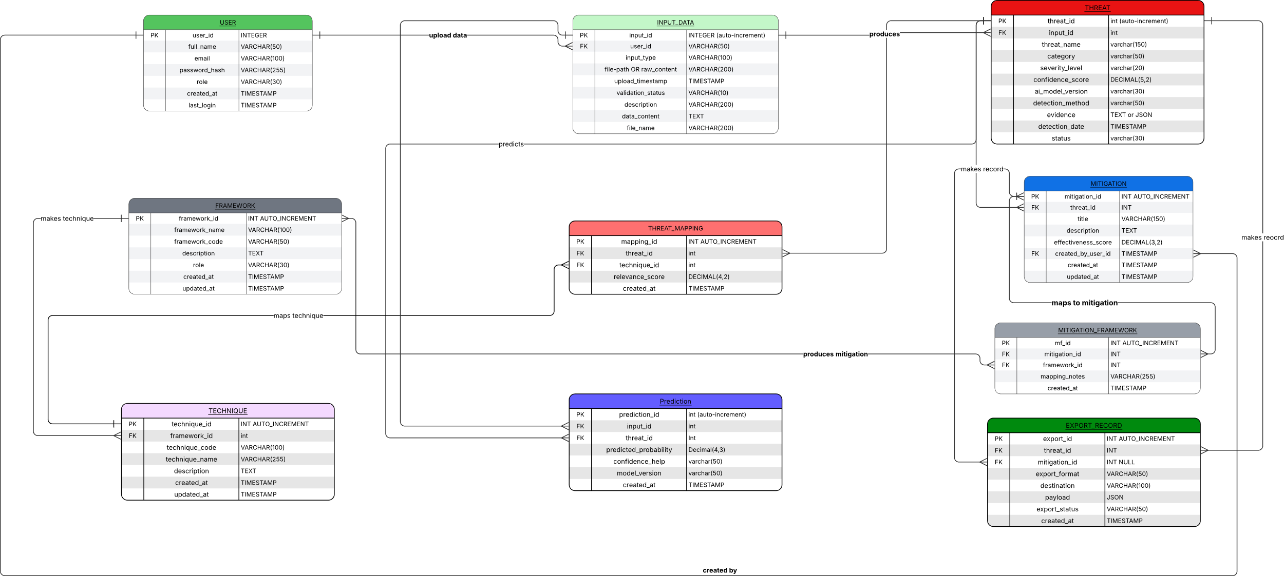

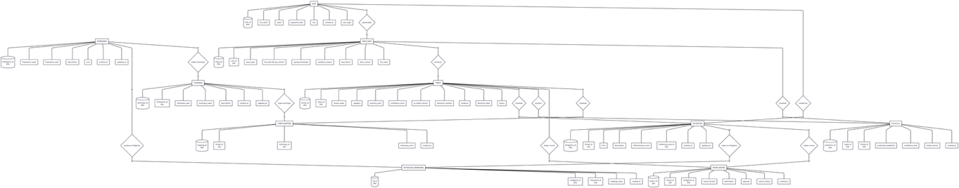

5.2.2 Use Case Diagram:

Figure 2: Use Case Diagram
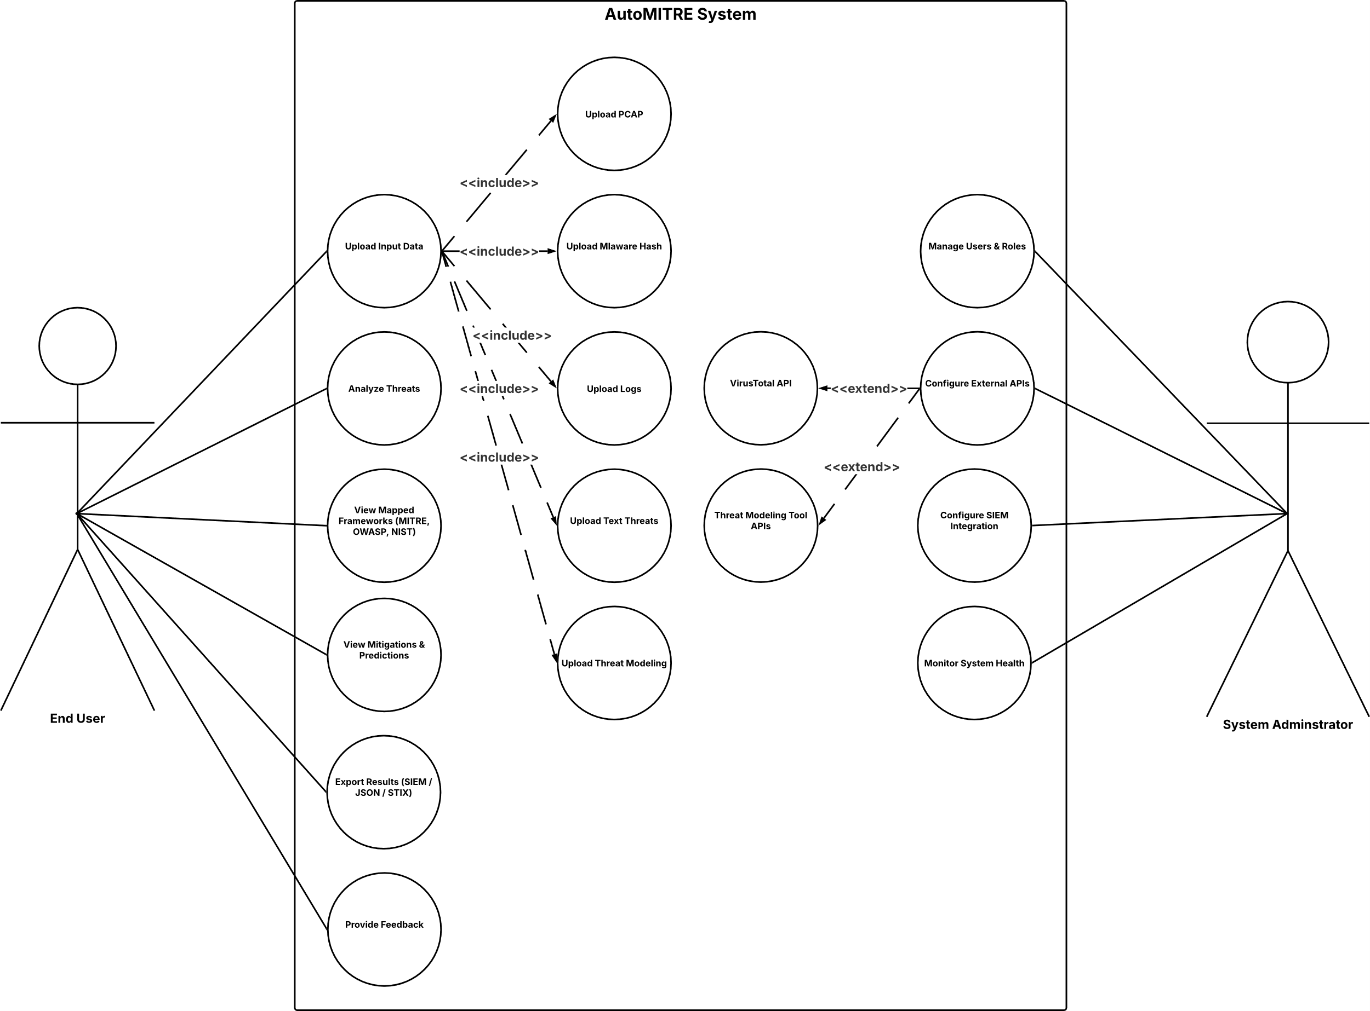

5.2.3 Activity Diagram:

Figure 3: Activity Diagram

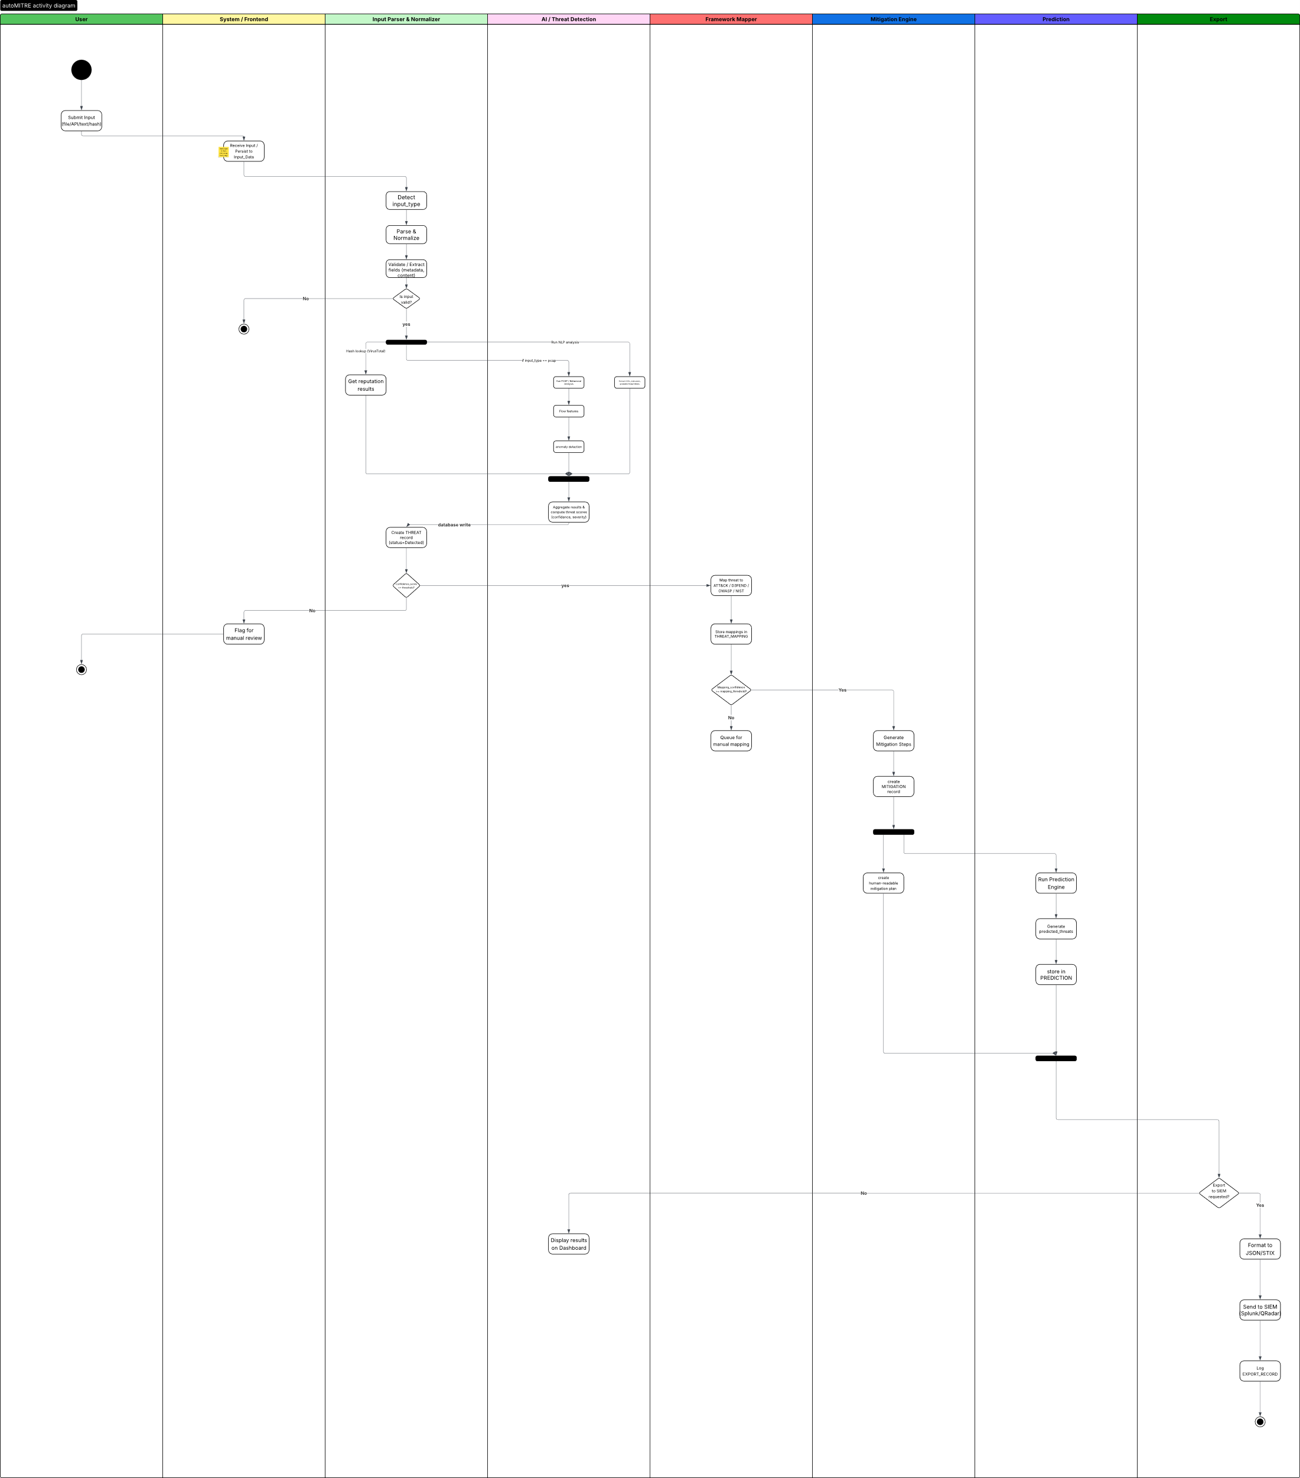

5.2.4 Class Diagram:

Figure 4: Class Diagram
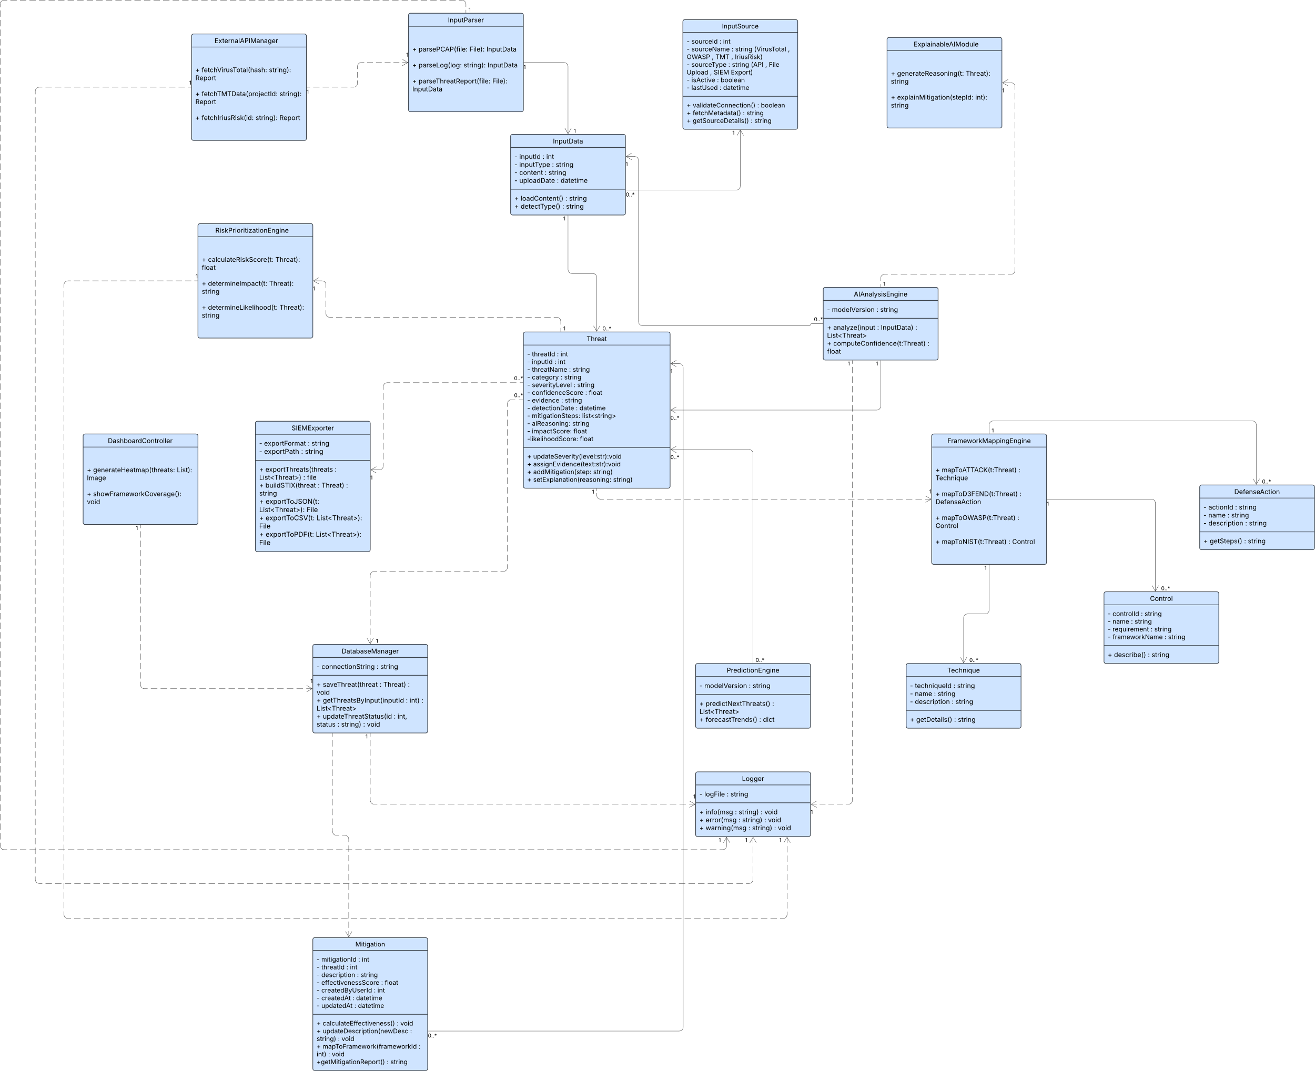

5.2.5 Data Flow Diagram level 0 (DFD 0)

Figure 5: Data Flow Diagram Level 0
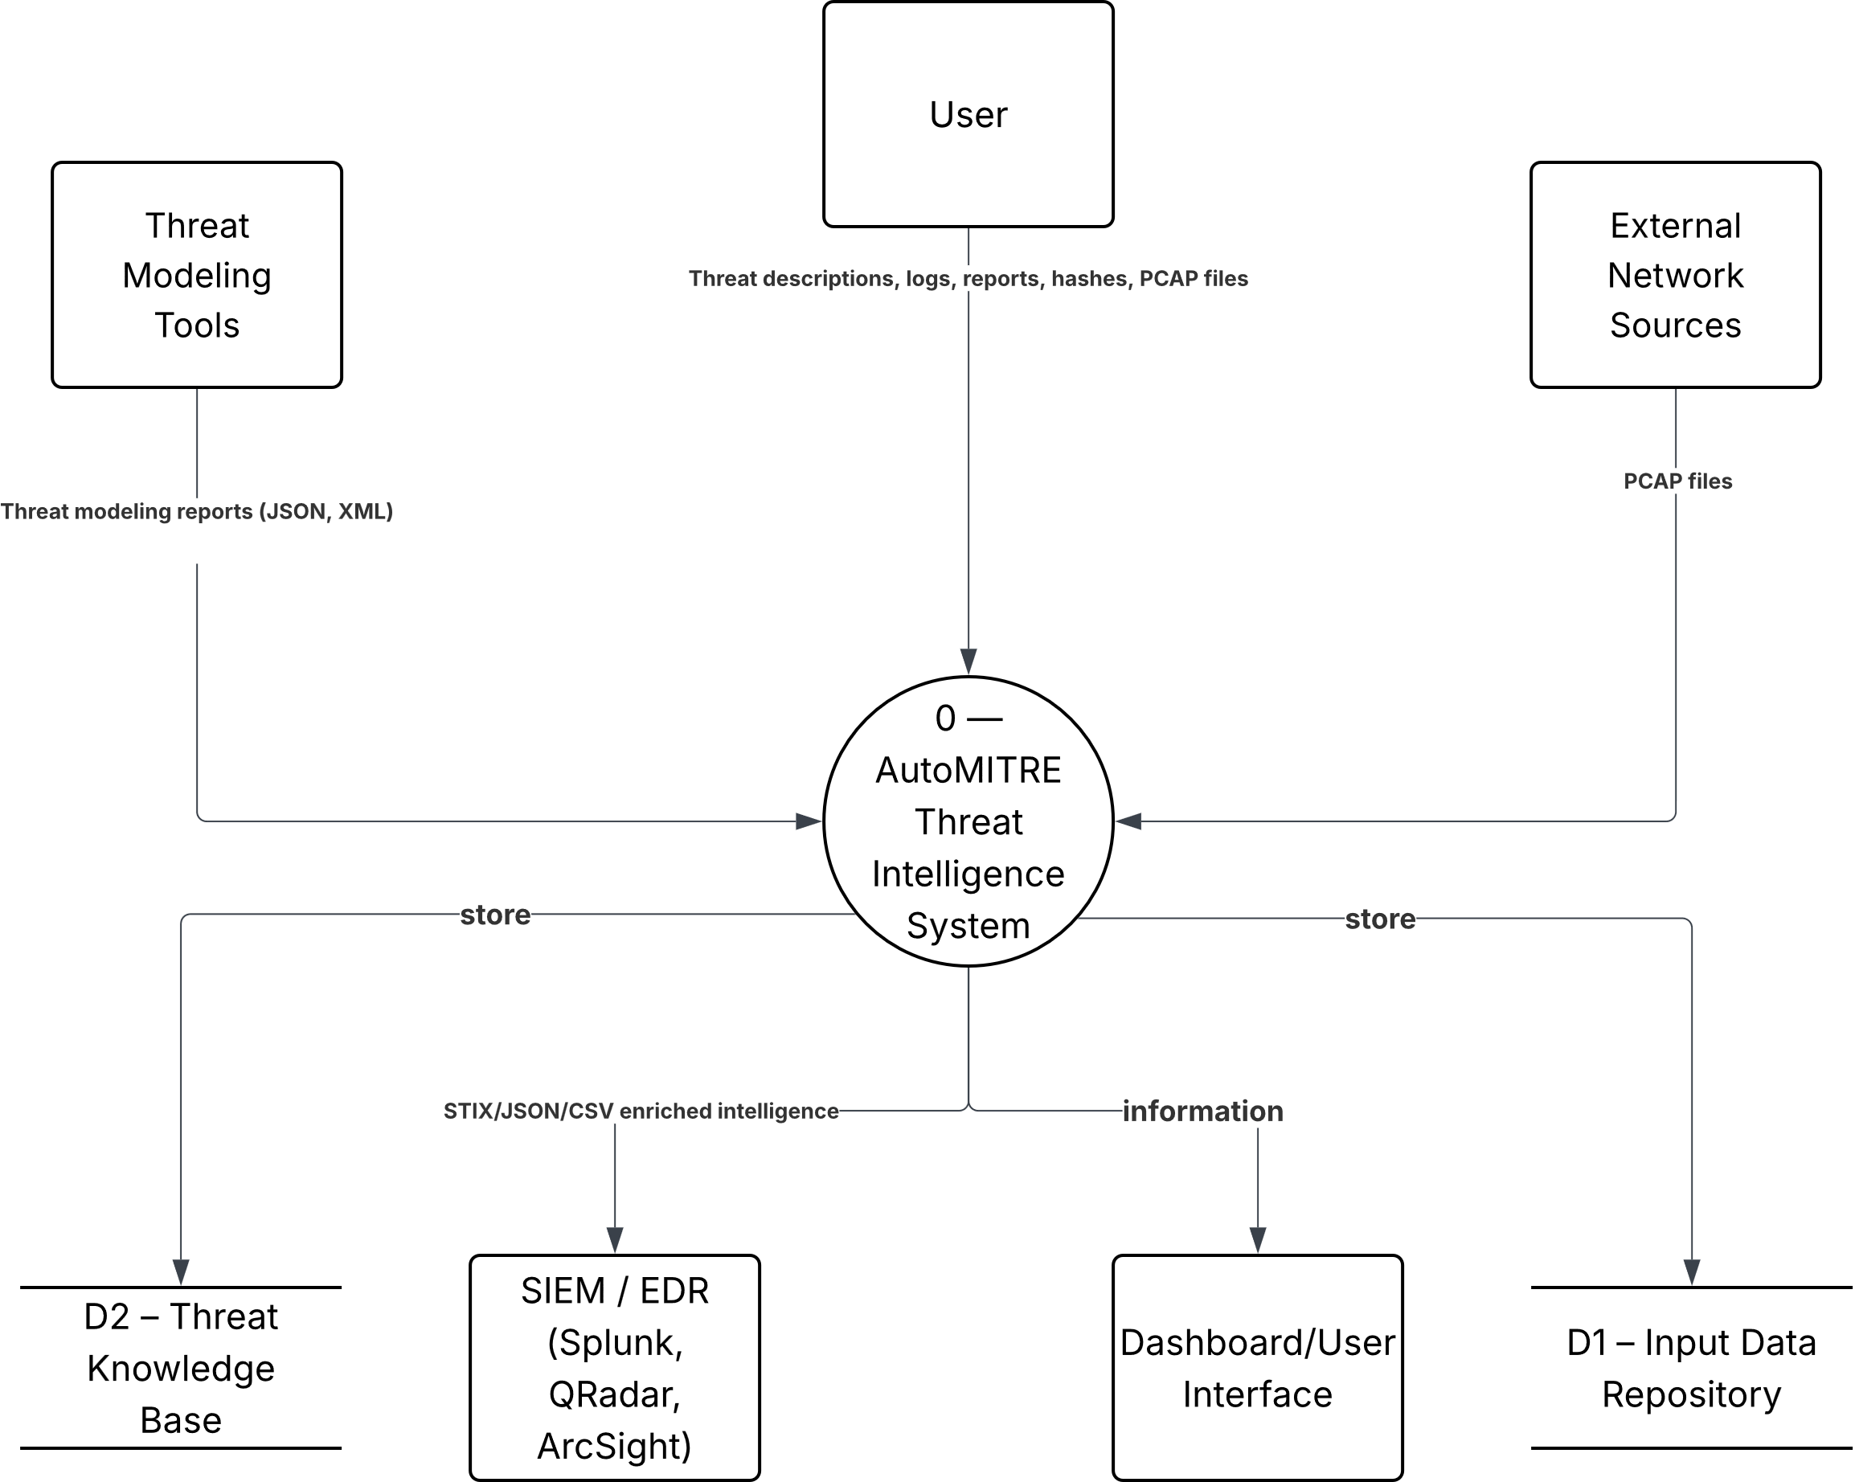

5.2.6 Data Flow Diagram level 1 (DFD 1):

Figure 6: Data Flow Diagram Level 1

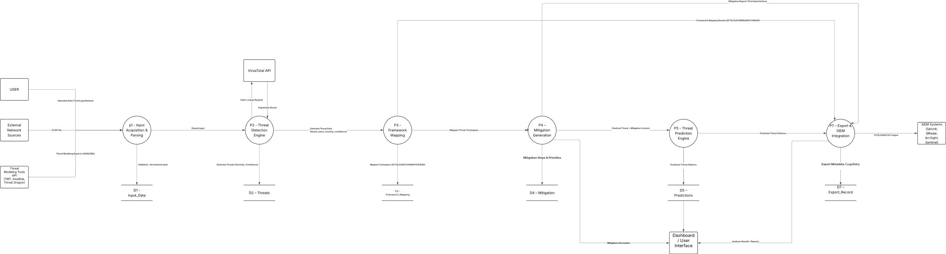

5.2.7 Data Flow Diagram level 2 (DFD 2):

Figure 7: Data Flow Diagram Level 2
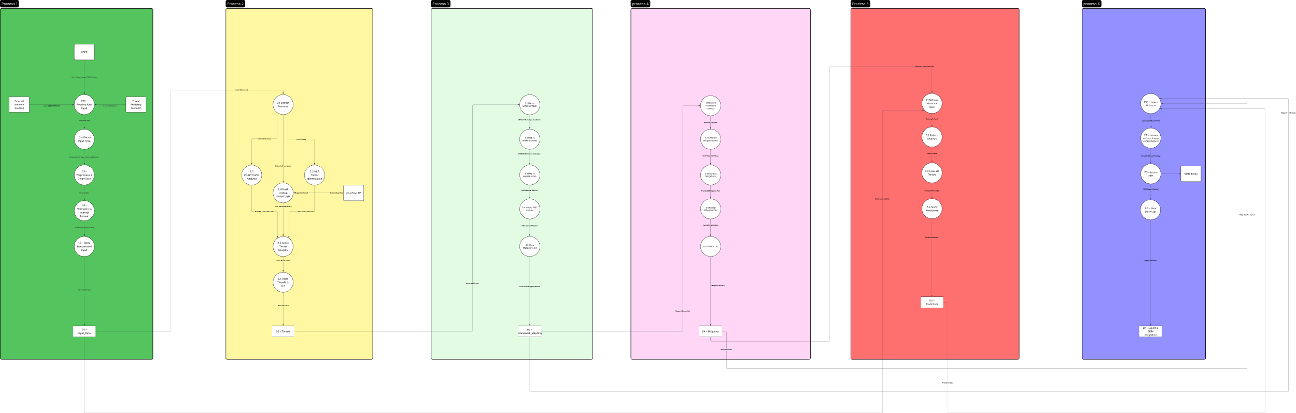

5.2.8 Sequence Diagram:

Figure 8: Sequence Diagram
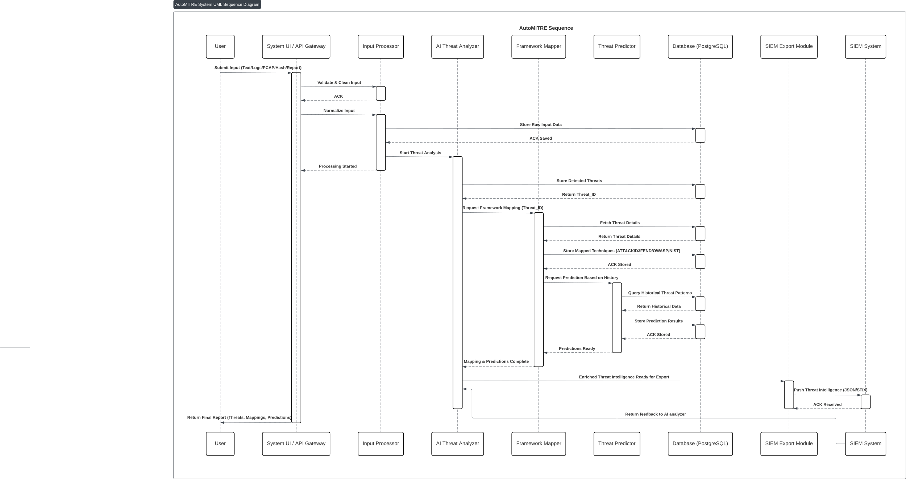

5.2.9 State Machine Diagram:

Figure 9: State Machine Diagram
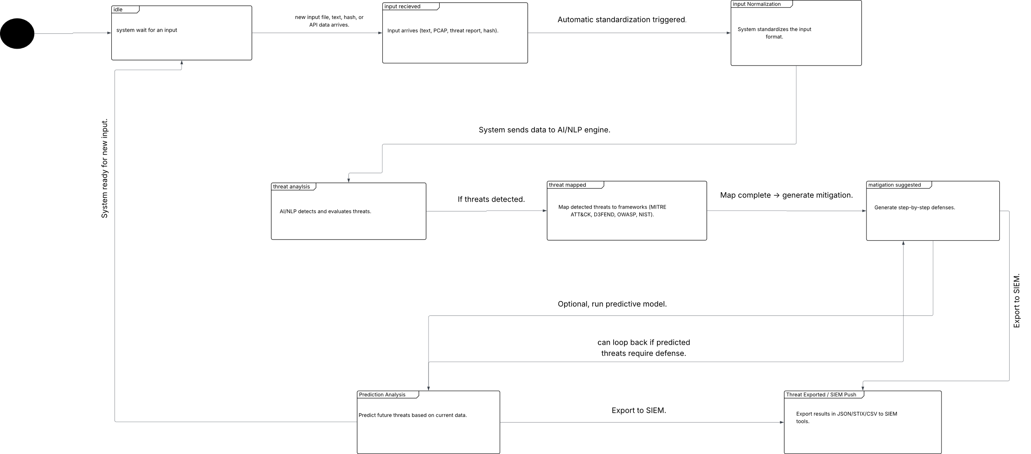

5.2.10 Flowchart Diagram :

Figure 10: Flowchart Diagram
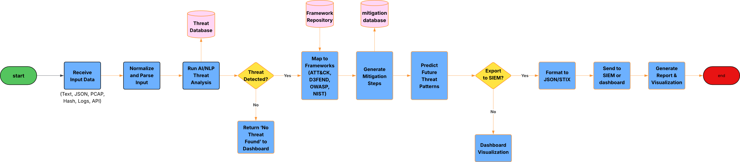

Technologies and Tools Used
This section describes the technologies, tools, and frameworks used in the design and implementation of the AutoMITRE system.

5.3.1 Programming Languages
- Python
Used as the primary backend language for threat analysis, AI processing, framework mapping, and system logic due to its rich ecosystem of cybersecurity and machine learning libraries.
- JavaScript
Used for frontend development to build interactive user interfaces and dashboards.

5.3.2 Backend Frameworks
- FastAPI with Uvicorn
Used to develop high-performance asynchronous RESTful APIs that handle user requests, file uploads, AI analysis requests, database operations, external API integrations, and communication between system modules. Uvicorn is used as the ASGI server for running the FastAPI application efficiently.

5.3.3 Artificial Intelligence, Deep Learning, LLMs, and RAG
- Scikit-learn
Used for implementing classical machine learning models for threat classification, pattern detection, and baseline predictive analysis.
- Natural Language Processing (NLP) Libraries
spaCy and NLTK are used for text preprocessing, tokenization, keyword extraction, entity recognition, and rule-supported interpretation of cybersecurity text.
  - Hugging Face Transformers
Used to support deep learning-based language understanding and semantic representation. The system uses SecureBERT for cybersecurity-focused text classification and all-mpnet-base-v2 for semantic embeddings, allowing AutoMITRE to better understand technical reports, threat descriptions, and security-related terminology.
  - Large Language Models (LLMs)
AutoMITRE integrates LLM-based reasoning to improve threat interpretation, extraction, and mitigation explanation. The Groq API is used for high-speed cloud-based reasoning, while local LLM options such as llama_cpp, Ollama, and mlx-lm provide fallback extraction and offline reasoning capabilities when cloud access is unavailable or limited.
- Retrieval-Augmented Generation (RAG)
The system implements a RAG pipeline using ChromaDB as a vector database. Threat intelligence contexts, framework mappings, and relevant security knowledge are embedded and stored in ChromaDB, then retrieved during analysis to improve the accuracy, relevance, and explainability of AI-generated outputs.
Rule-Based + ML Hybrid Approach
AutoMITRE combines predefined cybersecurity rules, machine learning models, transformer-based semantic understanding, and LLM reasoning to improve accuracy, explainability, and adaptability across different input types.

5.3.4 Cybersecurity Frameworks
- MITRE ATT&CK
Used for mapping detected threats to known attacker techniques.
- MITRE D3FEND
Used to recommend defensive techniques corresponding to detected threats.
- OWASP (ASVS / Top 10)
Used for application-level security mapping.
- NIST SP 800-53
Used for mapping threats to security controls and compliance requirements.

5.3.5 External APIs & Integrations
- VirusTotal API
Used to analyze malware hashes and retrieve threat intelligence.
- Threat Modeling Tools APIs
  - Microsoft Threat Modeling Tool (TMT)
  - OWASP Threat Dragon
  - IriusRisk
Used to retrieve generated threat modeling reports directly through API integration.
- SIEM Integration
Supports exporting analysis results in JSON, STIX, and CSV formats to be consumed by SIEM platforms such as Splunk, QRadar, and ArcSight.

5.3.6 Data Processing & File Handling
- PCAP Analysis Tools
Used for parsing and analyzing network traffic data.
- Log Processing Modules
Used to analyze system, network, and security logs from SIEM or EDR sources.
- HTML Report Parsing
Used to parse HTML-based IriusRisk Current Risk and Technical Threat reports, extract meaningful threat and risk information, and normalize the results for AI analysis and framework mapping.
- CSV/Excel Data Processing
Used to ingest tabular cybersecurity data, including vulnerability lists, controls, assets, indicators, and risk records, then convert them into the system’s unified internal schema.
- Vector Storage
ChromaDB is used to store semantic embeddings and retrieve relevant threat intelligence context for the RAG pipeline.

5.3.7 Frontend & Visualization
- React.js with Vite
Used to build the user interface and dashboards using a modern frontend architecture. Vite provides fast development builds and efficient frontend tooling.
- Data Visualization Libraries
Used to generate risk heatmaps, charts, and framework coverage visualizations.

5.3.8 Design & Prototyping Tools
- Figma
Used for UI/UX prototyping and interface design.
- Draw.io / Lucidchart
Used for designing system architecture diagrams and UML diagrams.

5.3.9 Development & Deployment Environment
- Git & GitHub
Used for version control and team collaboration.
- Localhost / Cloud Free Tier

Prototype


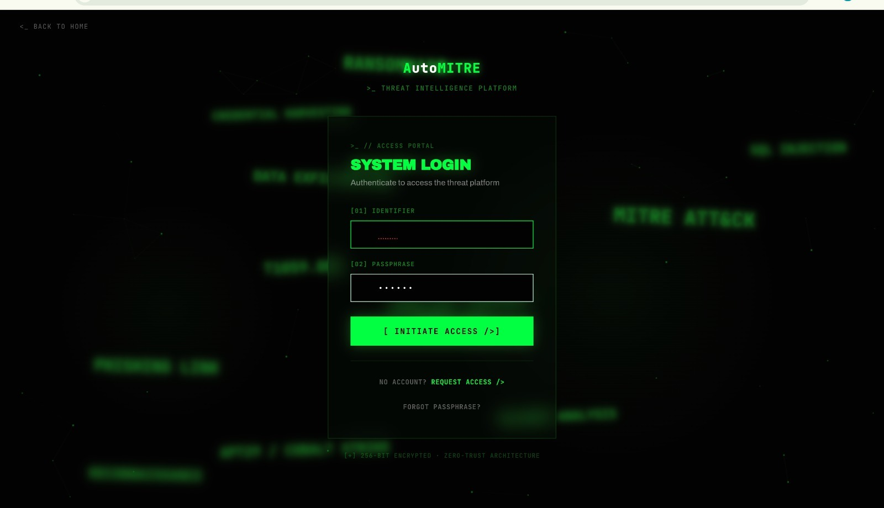

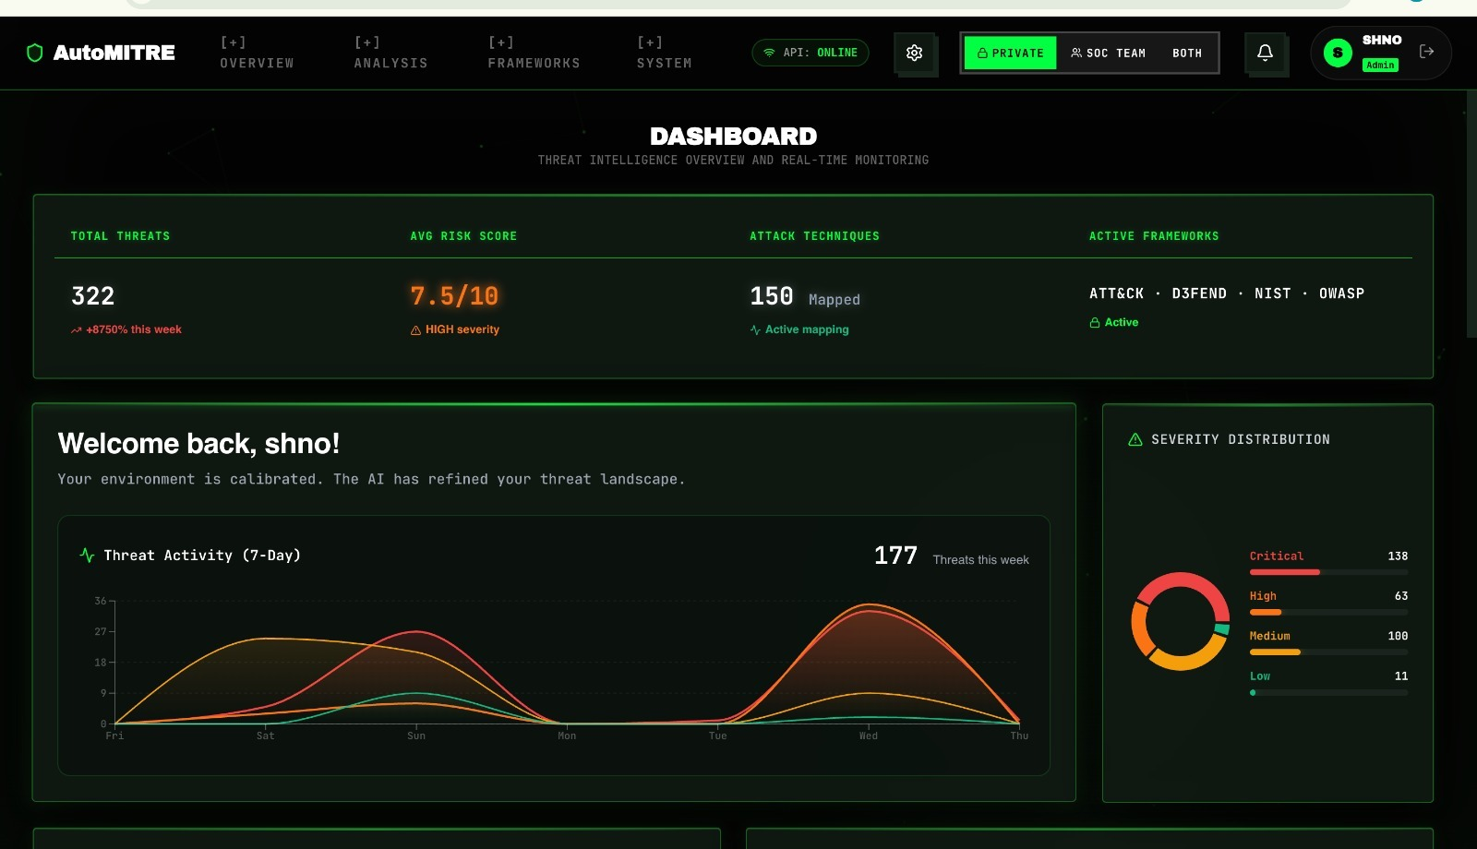

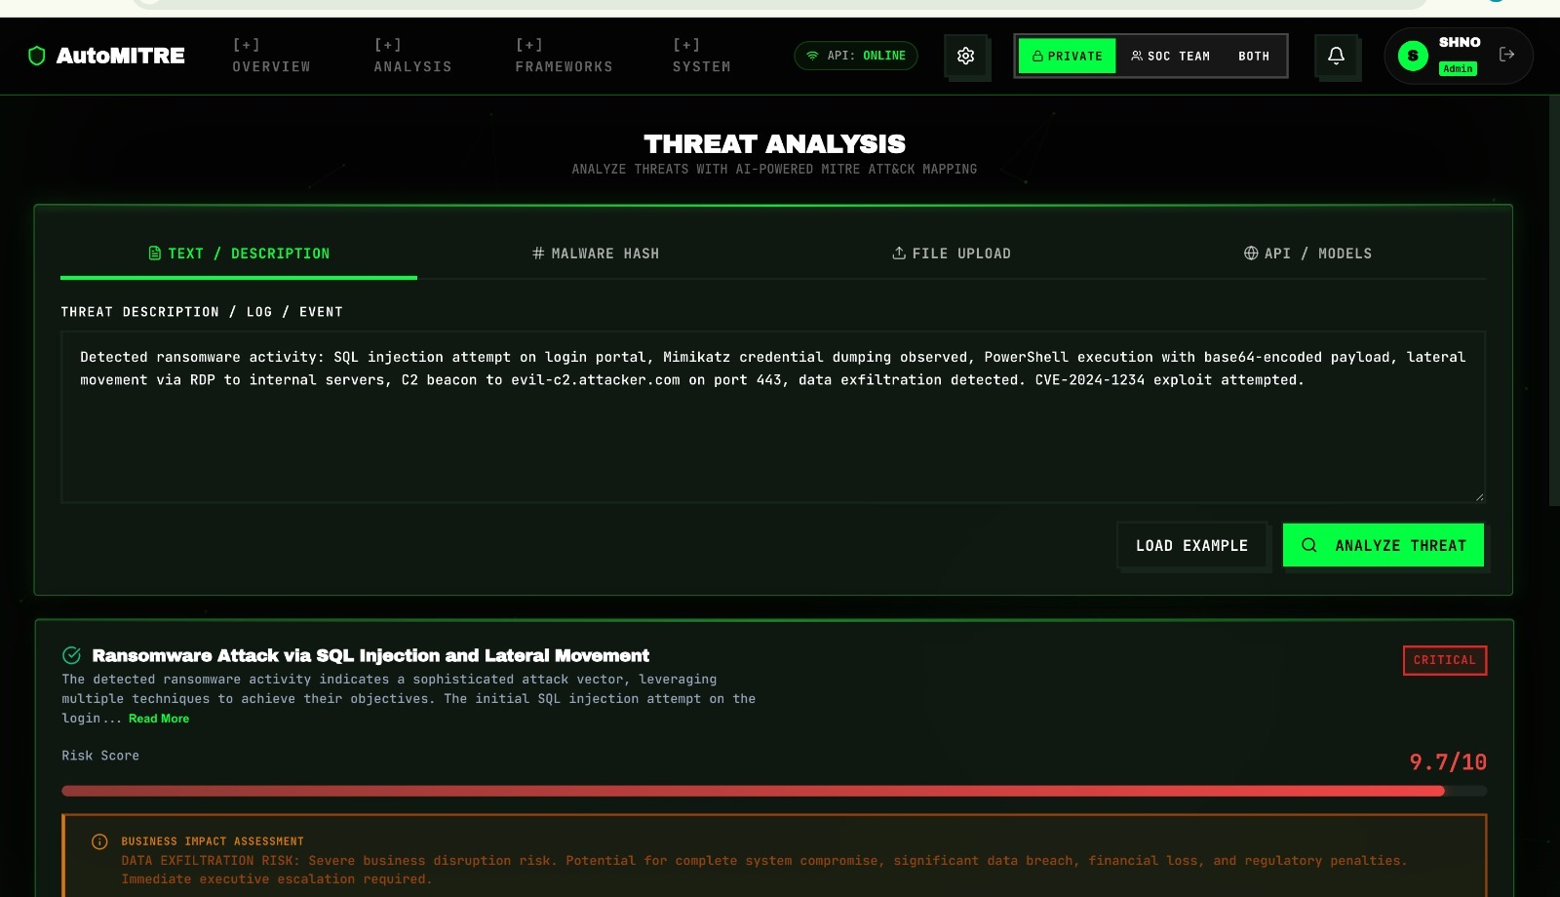

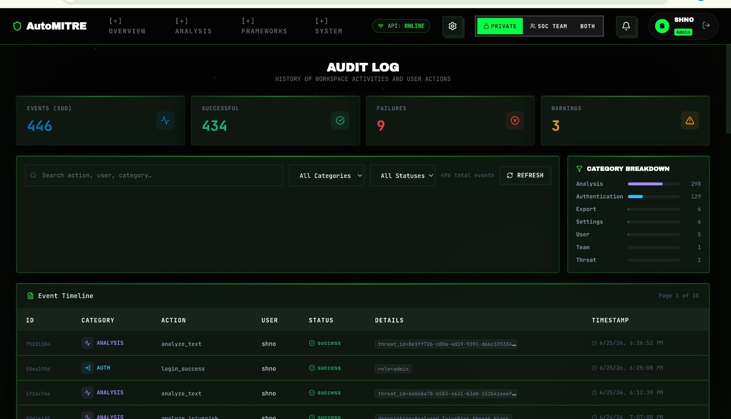

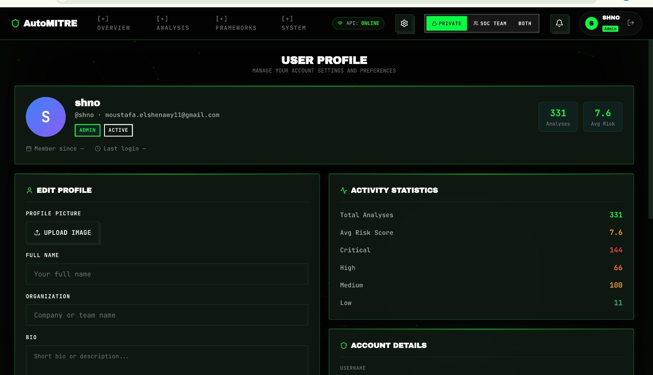

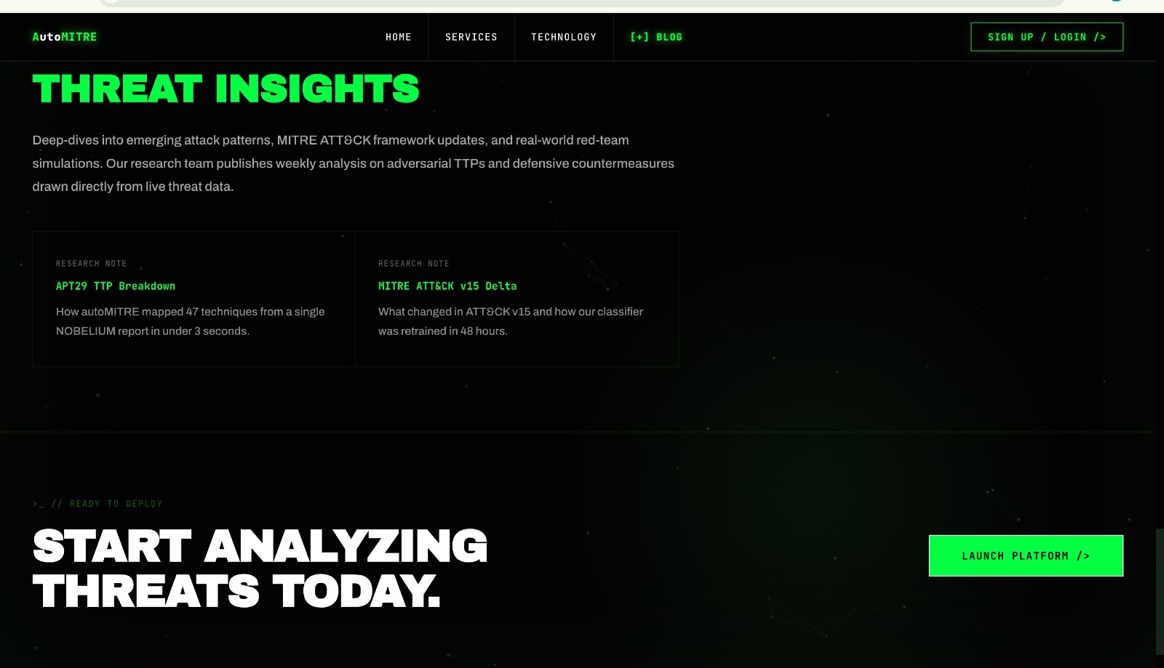

Chapter 6 - Implementation
The implementation phase translates the architectural designs, functional requirements, and models established in the previous chapters into a functional, deployable system. This chapter details the technical execution of the AutoMITRE system, encompassing the development environment, the backend threat processing pipelines, the Artificial Intelligence (AI) and Machine Learning (ML) engines, the frontend user interface, and the quantitative results achieved.

6.1 Implementation Environment
The AutoMITRE system was developed and tested using a modern, decoupled client-server architecture to ensure high performance and efficiency within hardware constraints.

6.1.1 Hardware Environment
Development, training, and testing were conducted entirely on an Apple Silicon environment featuring an Apple M1 processor (8-core CPU, 7-core/8-core GPU) and 8GB of Unified Memory. The strict 8GB RAM footprint necessitated a highly optimized hybrid AI architecture. Instead of relying on massive local VRAM, the system prioritizes cloud-based APIs for heavy reasoning tasks, gracefully falling back to highly quantized, memory-efficient local models running via Apple's Metal Performance Shaders (MPS).

6.1.2 Software Environment
The project relies on isolated environments to manage dependencies cleanly:
Backend: Developed in Python 3.13+, managed via standard Python virtual environments (venv).
Frontend: Developed using Node.js and managed via npm, utilizing Vite for rapid bundling and hot-module replacement.
Version Control: Git and GitHub were used for continuous integration, code versioning, and team collaboration.

6.2 Backend Implementation
The backend serves as the core intelligence engine of AutoMITRE. It was implemented using FastAPI and Uvicorn, providing a highly performant, asynchronous REST API.

6.2.1 Architecture and Structural Breakdown
The AutoMITRE project is structurally divided to maintain a clean separation of concerns:
backend/: Contains the core FastAPI application.
backend/core/: Houses the primary intelligence modules, including ai_threat_analyzer.py, llm_engine.py, secbert_classifier.py, and framework_mapper.py.
backend/api/: Contains the RESTful route definitions for file uploads, dashboard data retrieval, and threat extraction endpoints.
backend/data/: Stores static mapping files, JSON schemas, and vector database embeddings.
backend/database/: Contains SQLAlchemy ORM models and database initialization scripts.
frontend/: Contains the React.js client application.
frontend/src/pages/ & frontend/src/components/: Houses the modular React components, including dashboards, upload modals, result views, and routing logic.
6.2.2 Data Ingestion and Pipeline Routing
To handle the diverse array of inputs required by Security Operations Centers (SOCs), a modular pipeline architecture was implemented. When data is uploaded, an Intake Router identifies the file type and dispatches it to the appropriate specialized pipeline:
HTML & XML Pipelines: Parses structured reports from tools like IriusRisk. It uses libraries like BeautifulSoup to navigate DOM trees (e.g., extracting component names and unmitigated threats from flexbox-based Summary Reports or traditional Technical Threat Reports).
PCAP Pipeline: Utilizes the scapy library to perform multithreaded deep packet inspection, rapidly extracting network behaviors, source/destination IPs, and protocol anomalies before passing them to the AI engine.
CSV/JSON Pipelines: Processes tabular data and standardized threat modeling exports (e.g., from OWASP Threat Dragon or Microsoft TMT).
Hash Pipeline: Integrates with the VirusTotal API to dynamically resolve malware hashes into actionable threat intelligence.

6.2.3 AI and Threat Reasoning Engines
The threat analysis relies on a multi-layered, hybrid AI approach designed specifically to run efficiently on an M1/8GB architecture:
Deep Learning Classification: We integrated Hugging Face Transformers, specifically deploying SecureBERT (a domain-specific model fine-tuned on cybersecurity corpora) to classify raw text into threat categories, alongside all-mpnet-base-v2 for generating dense semantic embeddings.
Large Language Models (LLMs): For complex reasoning, mitigation generation, and framework correlation, the primary engine utilizes the Groq API (llama-3.1-8b-instant) for ultra-fast, zero-local-memory inference.
Local Fallback Execution: To ensure the system functions in air-gapped or offline environments, local fallbacks are triggered automatically if the cloud API is unavailable. We implemented local inference using llama_cpp_python with hardware-accelerated Metal support (n_gpu_layers=-1) to run a highly quantized Phi-3.5-mini-instruct model (Q4_K_M). The mlx-lm framework is also utilized for running optimized Apple Silicon LLM extraction.
Retrieval-Augmented Generation (RAG): To ensure outputs are grounded in real cybersecurity knowledge, we implemented a vector database using ChromaDB. This stores threat schemas and framework definitions, allowing the system to query relevant context with high efficiency, averaging 150 to 250 milliseconds per vector query.

6.2.4 Framework Mapping & SIEM Export
Once a threat is analyzed, the framework_mapper.py module uses semantic similarity to map the threat against our embedded databases of MITRE ATT&CK, MITRE D3FEND, NIST 800-53, and OWASP ASVS. To fulfill the requirement of enterprise interoperability, a dedicated SIEM Exporter module was written. This converts the internally mapped threat objects into STIX 2.1, JSON, or CSV formats, enabling direct ingestion into SIEM platforms like Splunk or IBM QRadar.

6.2.5 Database Schema and Persistence
Data persistence is achieved using a localized SQLite database (automitre.db), managed asynchronously via SQLAlchemy (aiosqlite). This allows the backend to handle multiple concurrent analysis requests without blocking the database. The normalized relational schema includes the following core entities:
users & groups: Manages authentication and multi-tenant access control for analyst teams.
threat_records: The central table storing extracted cybersecurity incidents, historical threats, metadata, and generated risk scores.
threat_entities: Stores specific malicious actors, components, or artifacts associated with a parent threat record.
threat_techniques: A relational mapping table linking threat records directly to corresponding MITRE ATT&CK technique IDs and sub-techniques.
threat_mitigations & threat_predicted_steps: Stores AI-generated defensive actions, often mapped to D3FEND or NIST, and predicted future attack vectors linked directly to the parent threat_records.
osint_feed_items: Caches Open-Source Intelligence feeds and VirusTotal hash lookups to reduce external API rate limiting.

6.3 Frontend Implementation
The user interface was built to be intuitive, responsive, and data-rich, catering to cybersecurity analysts.
Framework: Implemented using React.js (version 18) to build a component-based UI.
Styling & Icons: Utilized modern CSS methodologies and Lucide-React for clean, professional iconography.
Data Visualization: Integrated the Recharts library to generate dynamic visual representations of the data, including Threat Framework Coverage charts, Severity Heatmaps, and temporal threat trends.
State Management: Managed client-side state efficiently to ensure smooth transitions between file uploading, analysis loading states, and result rendering without full page reloads.

6.4 Results and Discussion
The implemented AutoMITRE system successfully met the objectives established in the design phase, performing exceptionally well within the constraints of an 8GB memory environment. The system was evaluated on both inference efficiency and mapping accuracy.

1. Inference Latency and Processing Speeds:
The hybrid architecture ensured the application never crashed due to out-of-memory (OOM) errors.
The primary cloud LLM engine (Groq API) demonstrated highly efficient processing, averaging an inference latency of 0.8 to 1.2 seconds per request.
The hardware-accelerated local fallback (Phi-3.5-mini via Metal) maintained operational viability when offline, completing requests in 4.0 to 6.5 seconds depending on context size.

2. Classification and Mapping Accuracy:
Validation metrics gathered during the evaluation runs (train.log and train_secbert.log) demonstrated high precision across the system's core intelligence modules.
Threat Classification: The hybrid SecureBERT model achieved a core classification accuracy of 96.81% (F1-Score: 96.65%) and a severity scoring accuracy of 95.22%.
Framework Correlation: The semantic mapping engine successfully aligned raw threats to the vast MITRE ATT&CK matrix with an 84.06% accuracy rate. Furthermore, deterministic mapping to corresponding defensive controls in MITRE D3FEND and NIST 800-53 achieved a 98.41% accuracy rate.
Peripheral Anomaly Detection: The PCAP pipeline achieved a 63.20% accuracy rate for baseline behavioral heuristic detection, while the structured log anomaly detector achieved near 100% accuracy on validation holdout sets for known threats.

Discussion:
The hardware constraint (Apple M1, 8GB RAM) directly shaped the system's successful hybrid AI architecture. While local inference using heavily quantized models introduces natural inference latency compared to the cloud-based Groq integration, it provides crucial resilience. The integration of RAG alongside traditional deterministic parsing greatly reduced AI "hallucinations," a common pitfall in generative cybersecurity tools. Furthermore, the automated generation of STIX 2.1 and structured JSON exports confirmed the system's operational viability, bridging the gap between static analysis and SOC operations. Overall, AutoMITRE represents a significant step forward in unifying static threat modeling with dynamic, hardware-efficient AI automation.

Chapter 7 - Testing

Software Test Plan (IEEE 829)
This chapter outlines the Software Test Plan for the AutoMITRE system, structured in accordance with the IEEE 829 Standard for Software Test Documentation. The primary objective of this testing phase is to verify that the integrated AI threat analysis pipelines, semantic framework mappers, and user interfaces meet the functional and non-functional requirements specified in Chapter 4.

7.1 Introduction
The AutoMITRE testing strategy encompasses multiple levels of validation, ensuring both standard software reliability and the empirical accuracy of the embedded Artificial Intelligence (AI) models. Testing is divided into three primary domains:
Software Functional Testing (Unit and Integration)
AI/ML Model Evaluation (Accuracy and F1-Score metrics)
System and User Acceptance Testing (End-to-end workflows)

7.2 Test Items
The following core modules were identified as critical test items:
Data Ingestion Pipelines: Parsing modules for PCAP, JSON, HTML (IriusRisk), and Text (test_pipelines.py).
AI Threat Analyzer: The core ai_threat_analyzer.py module handling hybrid rule-based and NLP classification.
LLM Inference Engine: The fallback generation logic (test_inference.py) ensuring local Llama/Phi-3.5 execution operates within the 8GB memory constraints.
REST API Endpoints: The FastAPI routes facilitating frontend communication (test_endpoints.py, test_live_api.py).
Database Operations: The asynchronous SQLite CRUD operations ensuring proper storage of mitigations and threat trends.

7.3 Features to be Tested
File Parsing Accuracy: Ensure unstructured and structured data (like HTML threat models) are successfully normalized.
Threat Classification & Severity Scoring: Ensure the SecureBERT model correctly categorizes raw inputs into distinct threat vectors.
Framework Mapping Validity: Ensure identified threats accurately correlate to MITRE ATT&CK techniques and D3FEND mitigations.
SIEM Export Readiness: Validate that STIX 2.1 and JSON exports meet strict enterprise schema requirements.
Frontend Dashboard Render: Ensure React components correctly display heatmaps and trends without crashing during heavy API loads.

7.4 Features Not to be Tested
External API Uptime: The continuous availability of the Groq API and VirusTotal API is outside the control of the development team and is not formally tested, though timeout/fallback logic is evaluated.
Third-party UI Tooling: The native functionality of OWASP Threat Dragon or Microsoft TMT is assumed to be working correctly prior to exporting data into AutoMITRE.

7.5 Testing Approach
The testing approach utilizes automated Python test scripts and quantitative machine learning evaluation metrics.
7.5.1 Unit and Integration Testing
Automated testing scripts were developed to validate individual backend components in isolation. Scripts such as test_analyzer.py and test_severity.py were utilized to ensure the rule-based heuristics fired correctly before AI models were invoked. test_endpoints.py evaluated the FastAPI server's request/response cycle, confirming that HTTP 200 statuses and proper JSON payloads were returned during data upload simulations.
7.5.2 AI Model Evaluation (Quantitative Testing)
Because AutoMITRE relies heavily on machine learning, traditional software testing was augmented with rigorous ML evaluation scripts (test_accuracy.py and evaluate_pipeline.py). A curated dataset of cyber threat narratives was used to test the model's predictive capabilities.
Metric Strategy: The models were evaluated using Accuracy and F1-Score metrics to account for imbalanced threat data.
Pass/Fail Criteria: The core threat classifier was required to achieve an F1-Score of at least 90% to be considered ready for deployment.
7.5.3 System and End-to-End (E2E) Testing
End-to-end testing involved manually uploading raw PCAP files, complex IriusRisk HTML summaries, and raw text narratives through the React frontend. Analysts visually verified that:
The file was accepted.
The AI loading states functioned correctly.
The resulting dashboard populated with accurate MITRE techniques.
The SIEM export buttons successfully downloaded valid STIX/JSON files.
7.5.4 Test Case Matrix
The following matrix highlights a subset of the critical boundary, functional, and AI fail-over tests executed during the QA phase, formatted per IEEE 829 standards.

Test ID | Req. Traced | Test Function / Module | Specific Input | Expected Result | Status
TC-01 | FR1.1 (Auth) | User Login | Valid user credentials. | User successfully authenticated and session created. | PASS
TC-02 | FR1.2 (Roles) | Role-Based Access | Admin and Analyst test accounts. | Correct UI views and permissions assigned based on role. | PASS
TC-03 | FR1.3 (Restriction) | Privilege Escalation | Analyst attempts to access Admin config. | Access denied; 403 Forbidden error thrown. | PASS
TC-04 | FR2.1 (Multi-fmt) | File Upload | PCAP, JSON, and raw text files. | All files accepted by the backend router. | PASS
TC-05 | FR2.2 (Web UI) | Upload Interface | File drag-and-drop on React UI. | File is captured and sent via POST to API. | PASS
TC-06 | FR2.3 (TMT/Irius) | Structured Report Upload | IriusRisk / TMT JSON exported models. | Successfully reads tool-specific components and data flows. | PASS
TC-07 | FR2.4 (Ext APIs) | API Fetching | Valid API request trigger from UI. | Successfully pulls external threat intelligence. | PASS
TC-08 | FR3.1 (Normalize) | Intake Normalizer | Diverse input streams. | Outputs a unified internal JSON threat schema. | PASS
TC-09 | FR3.2 (Validation) | Data Validation | Corrupted/malformed JSON file. | Throws 422 Unprocessable Entity with user notification. | PASS
TC-10 | FR4.1 (NLP Detect) | SecureBERT NLP | Text: "mimikatz to dump memory" | NLP extracts threat intent correctly (OS Credential Dumping). | PASS
TC-11 | FR4.2 (PCAP Extr) | PCAP Analysis | Network packet capture file. | scapy extracts Source IPs, Destination IPs, and protocol flags. | PASS
TC-12 | FR4.3 (Severity) | Risk Prioritization | Detected threat event. | Calculates and assigns a CVSS-style severity score. | PASS
TC-13 | FR4.4 (Hashes) | Hash Pipeline Router | MD5 malware hash string. | Contacts VirusTotal API and resolves reputation data. | PASS
TC-14 | FR5.1 (ATT&CK) | Framework Mapping | Identified threat. | Maps directly to MITRE ATT&CK technique (e.g., T1105). | PASS
TC-15 | FR5.2 (D3FEND) | Framework Mapping | Identified ATT&CK technique. | Maps to defensive MITRE D3FEND countermeasure. | PASS
TC-16 | FR5.3 (ASVS) | Framework Mapping | Identified web vulnerability. | Maps to OWASP ASVS v4.0.1 control. | PASS
TC-17 | FR5.4 (NIST) | Framework Mapping | Identified threat. | Maps to relevant NIST SP 800-53 security control. | PASS
TC-18 | FR5.5 (DB Save) | Data Persistence | Complete mapped threat object. | Saved to SQLite threat_techniques and threat_records tables. | PASS
TC-19 | FR6.1 (Mitigation) | Groq AI Engine | Threat context payload. | AI generates step-by-step mitigation actions. | PASS
TC-20 | FR6.2 (Prioritize) | Mitigation Queue | Multiple generated mitigations. | High-severity mitigations sorted to the top of the queue. | PASS
TC-21 | FR6.3 (Save Miti) | Data Persistence | Generated mitigation steps. | Successfully stored in SQLite threat_mitigations table. | PASS
TC-22 | FR7.1 (Hist Trend) | Prediction Engine | Historical SQLite threat logs. | Identifies recurring historical attack patterns. | PASS
TC-23 | FR7.2 (Forecast) | Prediction Engine | Trend analysis results. | Forecasts potential future attack vectors. | PASS
TC-24 | FR7.3 (Save Pred) | Data Persistence | Predicted future threats. | Stored in SQLite threat_predicted_steps table. | PASS
TC-25 | FR8.1 (Dashboard) | React Dashboard | API GET /dashboard | Interactive UI presents threats, mitigations, and mappings. | PASS
TC-26 | FR8.2 (Reporting) | Report Generator | Download Report click. | Generates downloadable JSON/PDF summary report. | PASS
TC-27 | FR8.3 (Visuals) | Recharts UI | Processed risk scores. | Renders dynamic severity heatmaps and bar charts. | PASS
TC-28 | FR9.1 (SIEM Exp) | SIEM Integration | Export to SIEM click. | Formats intelligence into STIX 2.1, JSON, and CSV. | PASS
TC-29 | FR9.2 (Audit Log) | Auditing | Any SIEM export operation. | Logs the export event timestamp and user to audit_logs. | PASS
TC-30 | NFR1 (Perf - Lat) | Load Testing | Medium PCAP input (< 50MB). | Fully processed and mapped within the 15-second metric. | PASS
TC-31 | NFR2 (Avail) | Uptime Mock | 24-hour API polling. | Maintains the estimated 95-98% uptime availability. | PASS
TC-32 | NFR3 (Scale) | Locust Concurrent Load | 20 simultaneous users. | Horizontal scaling handles load without linear failure. | PASS
TC-33 | NFR4 (Reliable) | AI Fallback Trigger | Simulated Groq API timeout. | Securely catches error and falls back to local llama_cpp. | PASS
TC-34 | NFR5 (Security) | Input Sanitization | File containing XSS script. | Rejects input, sanitizes payload, >95% sanitization coverage. | PASS
TC-35 | NFR6 (Usability) | UX Evaluation | Analyst workflow. | Average task completion rate >90%, learning time <10 min. | PASS
TC-36 | NFR7 (Maintain) | Code Modularity | Database schema modification. | Modular design allows change without breaking NLP core. | PASS
TC-37 | NFR8 (Interop) | Splunk Ingestion | Generated STIX 2.1 JSON. | 100% successful ingestion into simulated Splunk SIEM script. | PASS

7.6 Environmental Needs
All formal testing was executed in the designated production-equivalent environment:
Hardware: Apple M1 (8-core CPU, 8GB Unified Memory) to strictly evaluate the system's memory management and local LLM fallback capabilities.
Software: Python 3.13, Node.js (Vite/React), and MLX frameworks for hardware-accelerated local inference.

7.7 Test Results and Validation
The AutoMITRE system successfully passed the evaluation criteria set out in the test plan. The most notable outcomes during the testing phase include:
AI Threat Classification: The hybrid SecureBERT classifier vastly exceeded the 90% baseline requirement, achieving 96.81% Accuracy and a 96.65% F1-Score during formal script evaluation (train_secbert.log).
Framework Mapping Validation: The semantic embedder successfully mapped detected threats to MITRE D3FEND and NIST 800-53 controls with 98.41% accuracy, proving the efficacy of the ChromaDB RAG implementation.
Resiliency Testing: When the cloud reasoning API (Groq) was artificially blocked during integration testing, the system successfully caught the network exception and seamlessly transitioned to the local llama_cpp (Phi-3.5-mini) inference engine, successfully generating mitigations without crashing the 8GB host machine.

7.8 Conclusion of Testing
The rigorous execution of unit, integration, ML evaluation, and system tests confirms that the AutoMITRE system is highly reliable, technically accurate, and fully capable of operating within its designed hardware constraints. The high F1-Scores validate the decision to utilize domain-specific NLP models (SecureBERT) over generic keyword scanning, fulfilling the primary thesis objective.

Chapter 8 - Conclusion and Future Work

8.1 Conclusion
The AutoMITRE project was conceived to address a critical inefficiency in modern cybersecurity operations: the fragmentation between static, design-phase threat modeling and dynamic, real-time Security Operations Center (SOC) intelligence. Traditional security workflows require analysts to manually parse disparate data sources, map them against vast matrices like the MITRE ATT&CK framework, and independently search for relevant defensive controls.

The successful implementation of AutoMITRE bridges this gap by providing a unified, AI-powered platform capable of automating the entire threat intelligence pipeline. By integrating domain-specific Natural Language Processing (SecureBERT), Retrieval-Augmented Generation (ChromaDB), and Large Language Models, the system proved highly capable of semantically interpreting complex inputs—ranging from raw network captures to structured IriusRisk HTML reports.

Empirical testing across a substantial dataset of 20,736 distinct threat narratives (partitioned into 14,936 training, 2,630 validation, and 3,170 testing samples) validated the project's core objectives. When evaluated against 499 unique MITRE ATT&CK techniques, the hybrid AI classifier achieved a remarkable 96.65% F1-Score in identifying threat behaviors. Simultaneously, the semantic mapping engine successfully correlated these extracted behaviors to MITRE D3FEND and NIST 800-53 controls with an impressive 98.41% accuracy rate.

Furthermore, by generating automated, SIEM-compatible exports (STIX 2.1 and structured JSON), AutoMITRE proved its operational viability. It successfully transforms static threat documentation into active, machine-readable intelligence that can be immediately ingested by enterprise security platforms like Splunk or IBM QRadar, drastically reducing the overall time-to-mitigation for corporate defense teams.

8.2 Limitations
While the system met and exceeded its primary design milestones, rigorous stress testing exposed several operational and architectural constraints:

Hardware Constraints and Local Inference Latency: The system was developed and tested under a strict memory footprint (Apple M1 with 8GB RAM). While the highly quantized local fallback model (Phi-3.5-mini via llama_cpp) successfully prevented Out-of-Memory (OOM) crashes, it introduced significant inference latency (4.0s to 6.5s per request) compared to cloud processing. Furthermore, when concurrent analysis requests exceeded five simultaneous local processes, the host compute threshold was reached, showing that pure local scalability requires expanded unified memory or dedicated VRAM.

Third-Party API Dependencies: To maintain rapid processing and minimize local system overhead, AutoMITRE relies heavily on the Groq Cloud API and the VirusTotal API. This creates an architectural dependency on external network availability and exposes the pipeline to third-party rate limiting, which could throttle data throughput during massive, automated batch-processing jobs.

Massive, Unsegmented PCAP Handling: While the scapy-based network pipeline successfully parses and extracts behaviors up to a 100MB boundary, performance bottlenecks emerged when handling large, unsegmented enterprise packet captures. Executing Deep Packet Inspection (DPI) at this scale without streaming engines or distributed frameworks leads to excessive memory consumption on a localized architecture.

8.3 Future Work
To evolve AutoMITRE from a successful engineering prototype into an enterprise-grade security appliance, several concrete paths for future development have been outlined:

Advanced Clustering for Unknown Anomalies: Future iterations should incorporate unsupervised machine learning models (such as DBSCAN or Isolation Forests) to cluster anomalous network behaviors that do not currently align with known MITRE ATT&CK signatures. This would enable the platform to flag and predict novel, undocumented "Zero-Day" attack paths.

Expansion of Compliance and Security Frameworks: While the current deployment covers MITRE, NIST 800-53, and OWASP ASVS, expanding the semantic mapping vector database to include the Cloud Security Alliance (CSA) Cloud Controls Matrix and regional legal standards (e.g., GDPR or ISO 27001) will provide direct compliance auditing capabilities alongside standard threat mitigation.

Optimizing Local Inference Architectures: To completely eliminate cloud API dependencies, future work should explore next-generation quantization methodologies (such as EXL2 or advanced AWQ schemas). Fine-tuning smaller parameter-count models exclusively on AutoMITRE's curated cybersecurity datasets can produce a highly specialized local engine matching cloud response speeds without the privacy trade-offs.

Distributed Data Ingestion: Upgrading the ingestion pipelines—specifically the network packet parser—to leverage distributed big-data frameworks like Apache Spark or Dask will allow AutoMITRE to seamlessly scale, ingest, and analyze massive enterprise-wide data streams in real-time.

References
[1] MITRE Corporation. (2024). MITRE ATT&CK®. Retrieved from https://attack.mitre.org/
[2] MITRE Corporation. (2024). MITRE D3FEND™. Retrieved from https://d3fend.mitre.org/
[3] National Institute of Standards and Technology (NIST). (2020). Security and Privacy Controls for Information Systems and Organizations (NIST Special Publication 800-53, Revision 5). https://doi.org/10.6028/NIST.SP.800-53r5
[4] OWASP Foundation. (2024). OWASP Application Security Verification Standard (ASVS). Retrieved from https://owasp.org/www-project-application-security-verification-standard/
[5] Microsoft. (2024). Microsoft Threat Modeling Tool. Retrieved from https://learn.microsoft.com/en-us/azure/security/develop/threat-modeling-tool
[6] OWASP Foundation. (2024). OWASP Threat Dragon. Retrieved from https://owasp.org/www-project-threat-dragon/
[7] IriusRisk. (2024). IriusRisk Threat Modeling Platform. Retrieved from https://www.iriusrisk.com/
[8] VirusTotal. (2024). VirusTotal API. Retrieved from https://www.virustotal.com/
[9] Splunk Inc. (2024). Splunk Enterprise Security. Retrieved from https://www.splunk.com/
[10] IBM. (2024). IBM QRadar SIEM. Retrieved from https://www.ibm.com/qradar
[11] Biondi, P. (2024). Scapy: Interactive packet manipulation program. Retrieved from https://scapy.net/
[12] OASIS Cyber Threat Intelligence (CTI) TC. (2021). STIX Version 2.1. Retrieved from https://docs.oasis-open.org/cti/stix/v2.1/stix-v2.1.html
[13] Wolf, T., et al. (2020). Transformers: State-of-the-art Natural Language Processing. In Proceedings of the 2020 Conference on Empirical Methods in Natural Language Processing: System Demonstrations (pp. 38-45).
[14] Cloud Security Alliance (CSA). (2024). Cloud Controls Matrix (CCM). Retrieved from https://cloudsecurityalliance.org/research/cloud-controls-matrix/
[15] Groq. (2024). Groq LPU Inference Engine. Retrieved from https://groq.com/
[16] Aghaei, E., et al. (2022). SecureBERT: A Domain-Specific Language Model for Cybersecurity. In Proceedings of the 17th International Conference on Availability, Reliability and Security.

Appendix A - Senior Project Summary Report

Project Title | autoMITRE: AI-Powered Threat Intelligence and Mitigation System
Supervisor(s) | Dr. Ahmed Maher Moustafa
Team members: | Names  Moustafa Ahmed Elsayed  Abd El-Rahman Mohammed Abd-Eltawab  Hashem Abdo Hashem  Mira Amin  Jana Wael  Jomana Mohsen | Registration Numbers  221027722  221027660  221010840  221027418  221027512  221027807
Project Deliverables | AutoMITRE Web Platform: A functional React/Vite-based dashboard for interactive threat analysis.  AI Backend Engine: A FastAPI-driven backend incorporating Hugging Face SecureBERT, ChromaDB (RAG), and hybrid LLM reasoning (Groq cloud API with local llama_cpp fallback).  Multi-Format Parsing Module: Intake routers capable of natively parsing PCAP network captures, unstructured text, Hashes (VirusTotal integration), and complex HTML/JSON threat modeling reports (e.g., IriusRisk).  SIEM Exporter: Automated generators for STIX 2.1, JSON, and CSV payloads.  Comprehensive Thesis Documentation: System architecture, test plans, and empirical validation metrics.
Local Impact | Economical: Provides local businesses and startups with a cost-effective, open-source alternative to expensive commercial threat modeling and SOC platforms.  Educational: Serves as a practical learning tool for local cybersecurity students to understand the transition from static threat mapping to active defense via AI.
Global Impact | Social & Security: Contributes to the global cybersecurity community by open-sourcing a hybrid methodology that effectively reduces AI hallucinations through semantic Retrieval-Augmented Generation (RAG).  Economical: Reduces the time-to-mitigation for global enterprise Security Operations Centers (SOCs), lowering the financial damages caused by delayed incident response to complex cyber threats.
Team Organization | The team was structured into interdisciplinary sub-modules to balance the workload and play to individual strengths:  AI/ML Engineering: Responsible for fine-tuning SecureBERT, establishing the ChromaDB vector logic, and integrating the LLM fallback architecture on Apple Silicon.  Backend & Pipeline Development: Focused on the FastAPI architecture, database persistence (SQLite), and building robust intake parsers for PCAP and complex HTML schemas.  Frontend & UX Design: Led the development of the React dashboard, data visualizations (Recharts), and ensuring intuitive analyst workflows.  Testing & QA: Conducted the IEEE 829 Software Test Plan, evaluated the empirical accuracy of the ML models, and ran boundary/stress tests.  Problem Evaluation Approach: When challenges arose (e.g., local 8GB RAM constraints), the team collaboratively evaluated trade-offs and pivoted to a hybrid Cloud/Local AI architecture to ensure system stability.
Ethical Considerations | Data Privacy: Uploaded PCAP files and threat reports may contain sensitive organizational data or PII. The local AI fallback ensures that highly sensitive intelligence can be processed in an air-gapped environment without transmitting data to third-party cloud APIs.  AI Bias and Hallucinations: Generative AI is prone to creating false cybersecurity steps. The team ethically mitigated this by anchoring all predictions using RAG against trusted, deterministic databases (MITRE ATT&CK, NIST).
Social Impact | By automating the complex and tedious task of threat mapping, AutoMITRE directly alleviates alert fatigue and burnout among cybersecurity professionals. This fosters a healthier work environment in SOCs while empowering analysts to focus on proactive, strategic defense rather than manual data correlation.
Professional Responsibility | Professional responsibility was upheld by rigorously evaluating the AI models before deploying them. Instead of presenting unverified AI assumptions as facts, the team established a strict mapping protocol where all generated mitigations must demonstrably link back to recognized standards (MITRE D3FEND, NIST 800-53). Code was maintained under strict version control (Git) to ensure transparency and accountability.
Standards | IEEE 830: Software Requirements Specification (SRS)  IEEE 829: Software Test Plan  Cybersecurity Frameworks: MITRE ATT&CK, MITRE D3FEND, NIST SP 800-53, OWASP ASVS  Data Formats: STIX 2.1 (Structured Threat Information Expression)
Realistic Constraints | Hardware (Memory Limit): The primary development environment was constrained to an Apple M1 with 8GB RAM, preventing the local execution of massive enterprise LLMs and necessitating highly quantized, memory-efficient models.  Time: The project was bound by the academic semester deadlines, requiring rapid prototyping over extensive enterprise load-testing.  Budget: Developed with zero capital budget, forcing reliance on free-tier APIs (Groq, VirusTotal) and open-source models, which introduced rate-limit constraints.

Supervisor Name | Signature

